Report on activities of THE VOCATIONAL TRAINING AND LIFE SKILL DEVELOPMENT CELL, IQAC, LALA RURAL COLLEGE
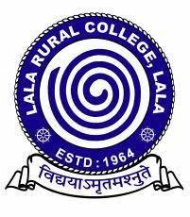
Session: 2020-21
Session: 2021-22
Session: 2022-23

SESSION: 2020-2021
The activities of Vocational Training and Life Skill Development Cell for the session 2020-2021 are as follows:
Vocational Training and Life Skill Development Cell's COVID-19 Awareness Initiative
In response to the ongoing COVID-19 pandemic, the Vocational Training and Life Skill Development Cell, IQAC, Lala Rural College, initiated a comprehensive awareness campaign aimed at promoting essential preventive measures. The campaign focused on raising awareness about proper mask usage, hand sanitization and effective hand hygiene through the strategic placement of informative banners and posters across the college campus. The primary objective was to educate students, staff, and visitors about the correct way to wear masks to maximize their effectiveness in preventing the spread of the virus. Another key goal was to emphasize the importance of thorough handwashing as a fundamental practice to reduce the risk of infection. The initiative aimed to highlight the significance of using hand sanitizers as an alternative to handwashing and to illustrate proper techniques. The initiative also aimed to enhance overall understanding of COVID-19, its transmission, and the significance of adopting preventive measures.
Engaging and informative banners and posters were designed by the Vocational Training and Life Skill Development Cell in collaboration with graphic designers. The content included visually appealing graphics and concise text that conveyed the key messages clearly. Banners and posters were strategically placed in high-visibility areas across the college campus, including entrances, corridors, and common areas. Banners highlighted the correct way to wear masks, covering both the nose and mouth. They emphasized the importance of wearing masks consistently, especially in crowded spaces. The campaign depicted proper hand sanitization techniques, including the amount of sanitizer to use and the areas of the hands to target. Step-by-step visuals and concise instructions illustrated the recommended handwashing procedure, underscoring the need for thoroughness. Proper handwashing techniques were demonstrated through step-by-step visuals, showcasing the recommended duration and areas to focus on. Banners and posters reminded individuals to maintain a safe distance from others and avoid close contact to reduce the risk of transmission
The initiative garnered positive responses from the college community. Students appreciated the informative banners and posters, and many reported improved awareness of proper mask usage and hand hygiene.

Enclosures:
- Photographs
Dr. Sonali Roy, Convener,
Vocational Training & Life Skill Development Cell, IQAC

Photographs:

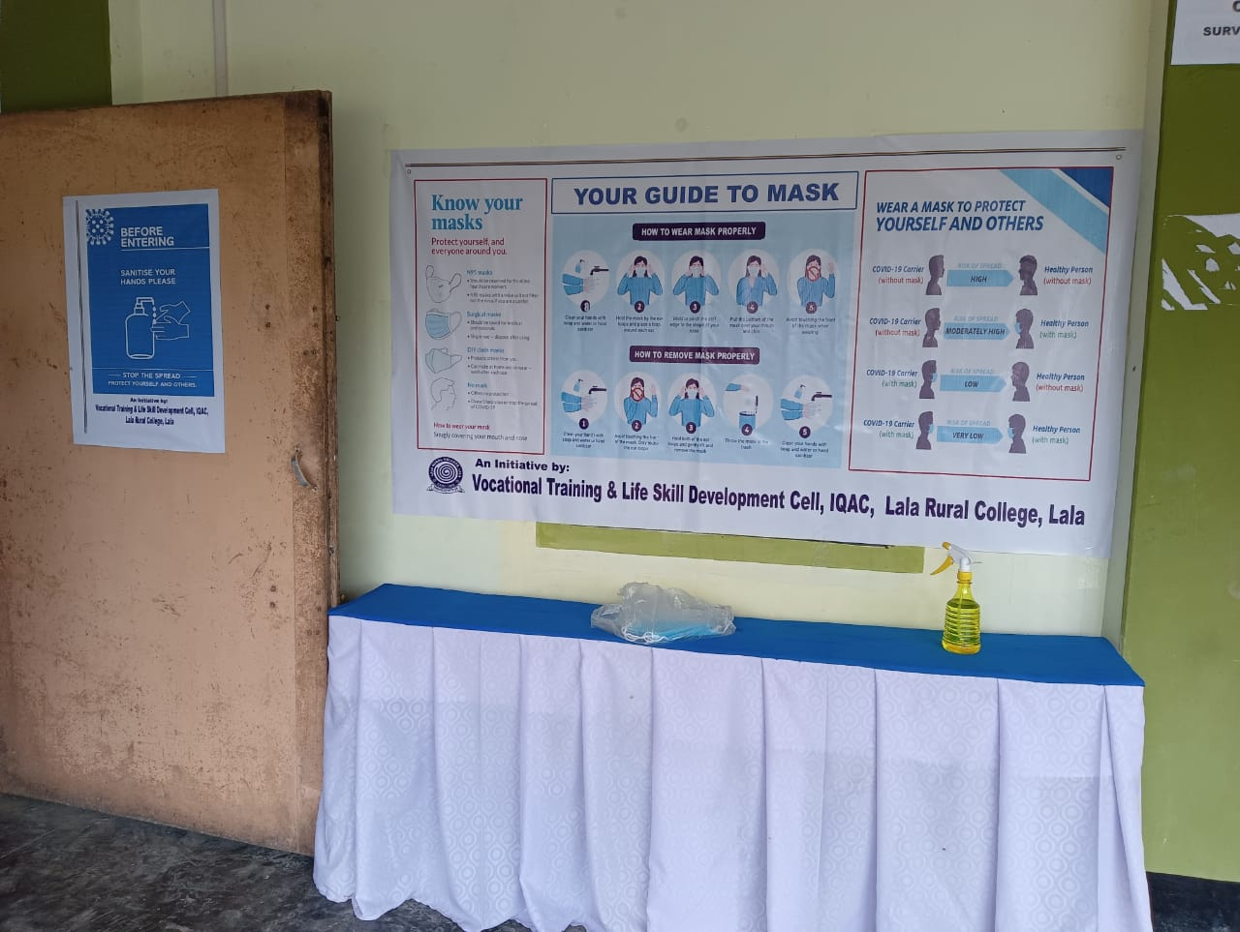

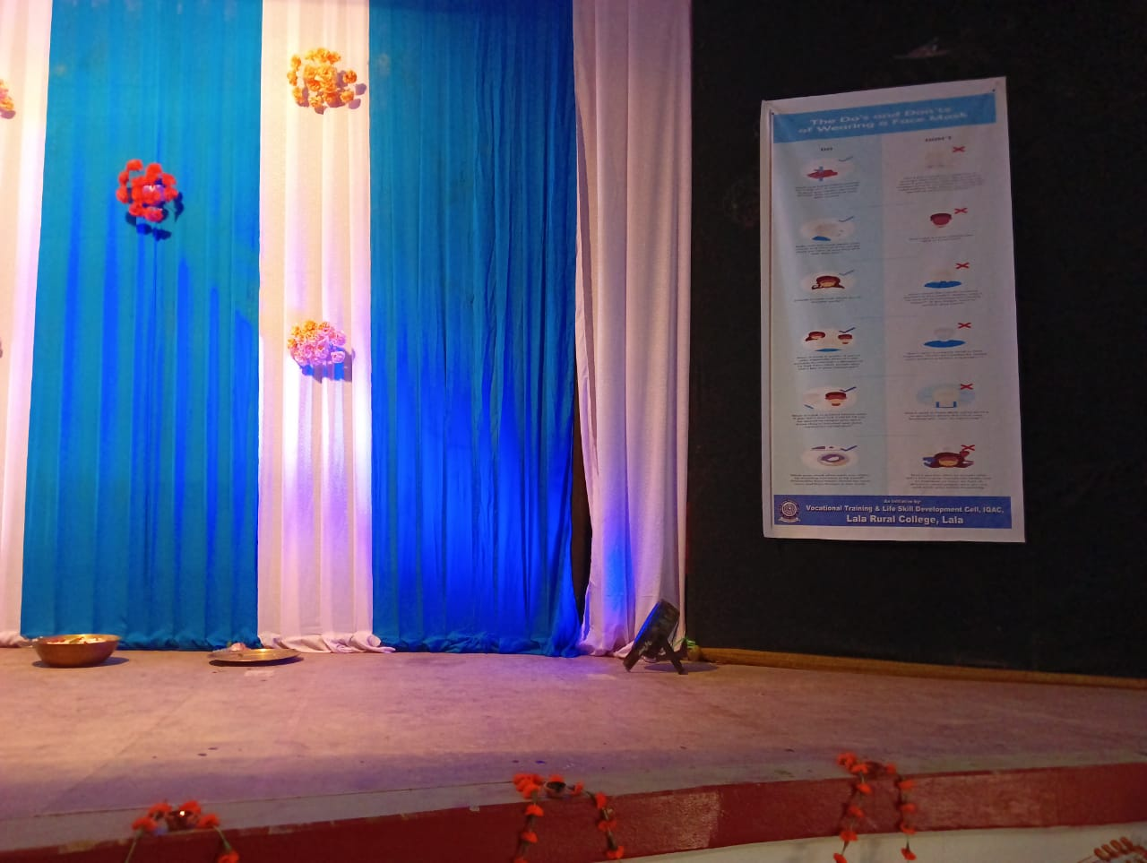

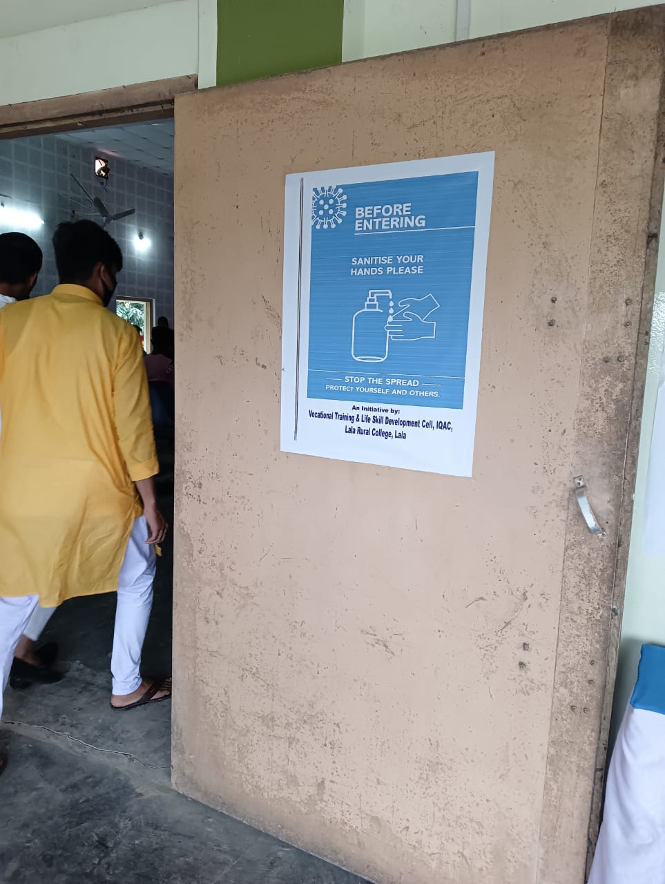

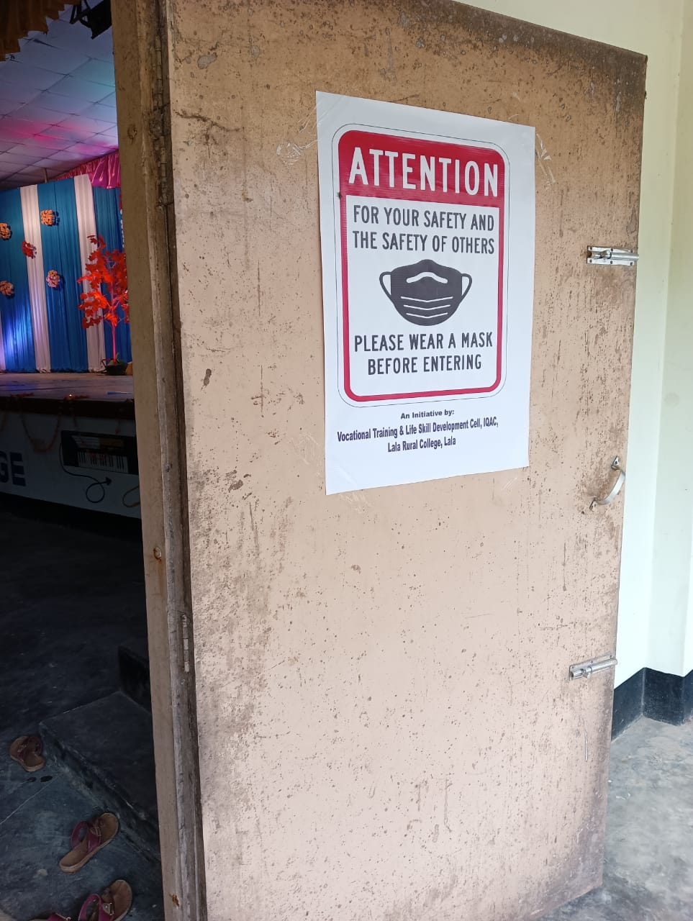

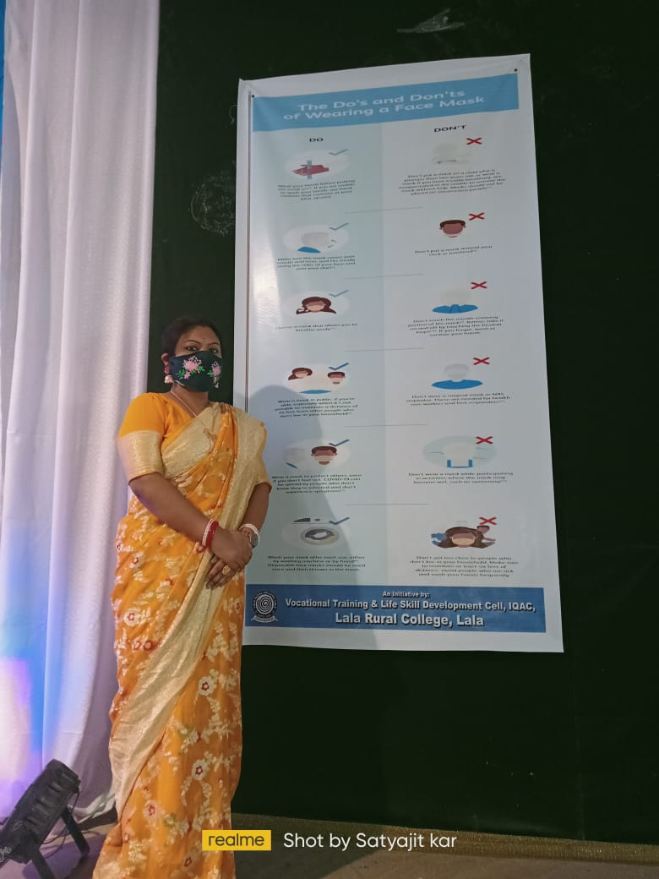

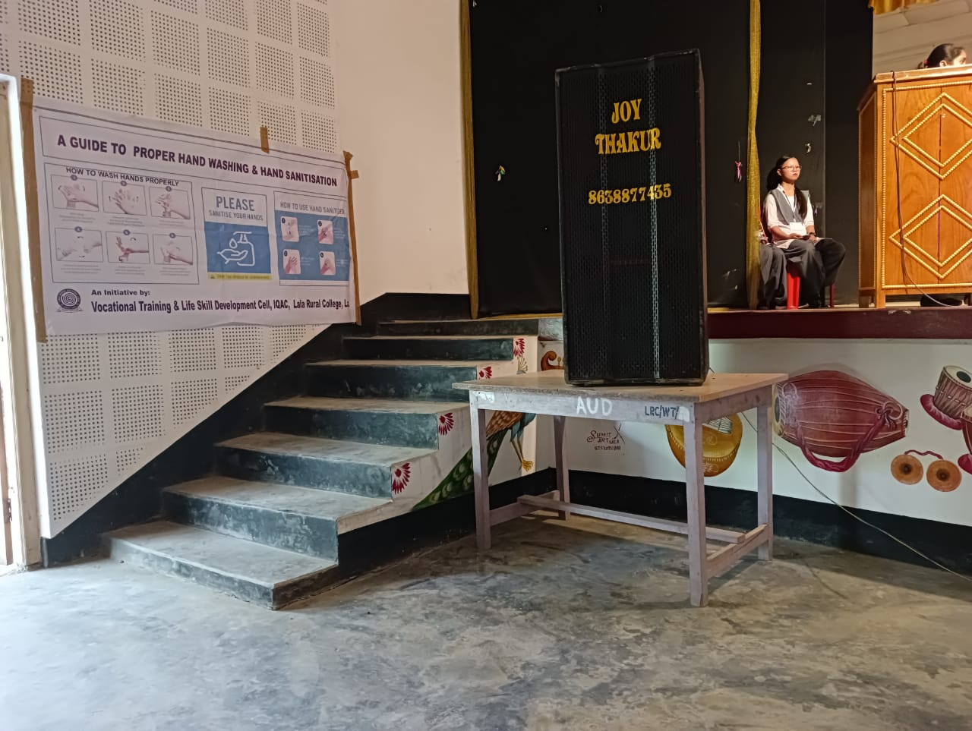

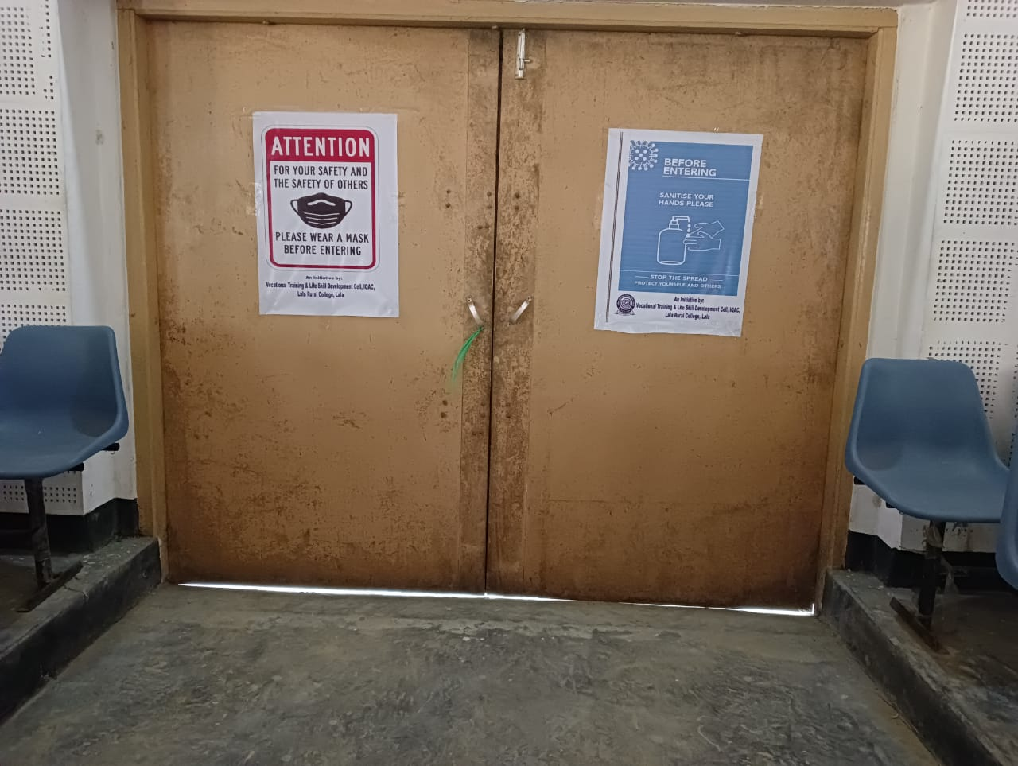

SESSION: 2021-2022
The activities of Vocational Training and Life Skill Development Cell for the session 2021-2022 are as follows:
15 Days Computer Training Course
Date: 21st May to 4thJune, 2022
Venue: Rongpur Part- I, Lala, Hailakandi

A Computer Training Programme/Course for the students was organized by the Vocational Training and Life Skill Development Cell, IQAC, Lala Rural College in collaboration with Mongaldip Infotech under Soft Skill Development Programme from 21st May to 4th June, 2022 with an objective to acquaint the students with knowledge of computer basics and applications.
The inaugural session began at 10.30 a.m. with opening remarks by Dr. Sonali Roy, Convener, Vocational Training and Life Skill Development Cell, IQAC, Lala Rural College. Dr. Tanuj Kumar Dey, Principal, Lala Rural College inaugurated the programme and gave his inaugural speech highlighting the importance of computer knowledge in today’s world.
A total of 30 students, both from Arts and Commerce Stream, participated in the programme. The training process was incredible and interesting, as the institution provided the environment/ space, instructors and training manual/ curriculum was distributed to each participant before the start of the process. All the sessions were very effective and fruitful for the participating students. The queries put forward were effectively answered by the efficient instructors of the institution.
The valedictory session was held on 4th June, 2022 at 4.00 p.m. It started with the speech of Dr. Tanuj Kumar Dey, Principal i/c. He emphasized on the fact that having an in-depth knowledge of computers is an invaluable skill to have these days. Since the extensive use of computers is bound to increase in the foreseeable future, computer skills will be really valuable. He also assured that the college would be organising more such training programmes in future to enhance the computer knowledge of the students of Lala Rural College. The programme wrapped up around 4:30 p.m. with the distribution of certificates and delivery of vote of thanks by Mrs. Deepmala Paul, Asstt. Professor and Member, Vocational Training and Life Skill Development Cell, IQAC. The college authority had given tremendous support and co-ordination in making this event a successful one. After completion of this workshop students have felt encouraged to explore these areas further.

Enclosures:
- Course Outline
- List of Participants
- Photographs
- Sample Certificates
- Attendance Sheet Dr. Sonali Roy, Convener,
Vocational Training & Life Skill
Development Cell, IQAC

Course Outline:

Topic | Sub -Topics
Computer Applications & Basics | Introduction, Basic Applications of Computer, Components of Computer, Connecting Computer Components, Computer Hardware & Software.
Computer Operating System | Basics of Operating System, Linux, Windows, Task Icons, Bars, System Settings, Setting Date & Time, File Management.
Word Processing | Introduction, Printing a File, Document Creation, Editing, Saving & Text Formatting,
Working with Graphs and Charts | Creating Charts using Char Wizard - Steps to Create an Embedded Chart, Steps to Create Separate Charts on a Chart Sheet. Sizing and Moving Charts. Updating Charts, Changing the Chart Type. Adding Titles and Gridlines and Formatting Legends -Adding a chart title, Adding gridlines and formatting legends. Previewing and Printing Charts.
Microsoft Excel, Spreadsheet & Worksheet | Introduction, Rows, Columns & Cells, creating and using multiple worksheets and linking workbooks.
Power point | Slides, Creating Power Point Presentation and Designing.
Database Management | Introduction, Adding Sort Codes, Sorting the Database, Basics of List, Finding Records, Using Wildcards, Filtering Records in a  Worksheet - Customizing filters, Using

 | multiple filters, Summarizing Data, Creating the Pivot Table.
Using Functions | Applying Functions - The Round Function, The Count Function, The Max Function, The Min Function, The Average Function, The Sum Function. Worksheet Function using Function Wizard, The VLOOKUP Function
Creating and Using Macros | Creating Macros, Recording Macros and Steps for recording a Macro, Recording the macro, Running a Macro. Documenting the Macros - Examine your macros, Step to add comments in a macro. Assigning Macros to Buttons - Creating Macro Buttons, Resizing a macro button, Moving a macro button. Running Macros with Macro Button, Using a Keyboard short-cut to Run Macro, Assigning a short-cuts key to a macro.
Introduction to Internet | WWW & Web Browsers, Basics of Computer Network, Internet, Search Engines, URLs, How to Use Web Browser? An Overview of Computer Viruses, Basics of Email, How to Use Email, Instant Messaging, Formatting an Email.
Integrating Excel with Word and the Internet | Integrating Worksheet Data and Charts with Word, Creating an Embedded Worksheet Object in Word Document, Creating a Hyperlink to a Word Document, Using the Internet Assistant Wizard to Convert Worksheet Data and Charts to Web Pages.

Creating Web | Creating a Web Page from a wizard, Creating a web page from a Template, Converting a Word Document to a Web page.
MS ACCESS | Ms Access Database Components, Introduction to Database - Creating Database- Wizard, Creating Tables Wizard, Design View, Datasheet View. Basic Structure of Tables – Field Names, Data Types, Description, Properties. Creating Queries - Opening Queries, Design View, Datasheet View, Closing Queries. Introduction to Form - Opening a Form, Types of Forms, Designing a Form Wizard, Navigating in Forms, Finding Records in Forms. Introduction to Reports - Opening and Viewing Reports, Types of Reports, Forms and Reports, Closing and Saving Reports.

List of Participants:

Sl. No. | Name | Class
1 | Ksh. Albeto Singha | TDC II Sem (C)
2 | Anwar Shahid Laskar | TDC II Sem (C)
3 | Nikita Modak | TDC II Sem (A)
4 | Tina Dey | TDC II Sem (A)
5 | Priya Nath | TDC II Sem (A)
6 | Ampi Nath | TDC IV Sem (A)
7 | Poheli Nath | TDC IV Sem (A)
8 | Puja Nath | TDC II Sem (A)
9 | Piyali Roy | TDC IV Sem (A)
10 | Taposhi Ghosh | TDC IV Sem (A)
11 | Satyajit Kar | TDC IV Sem (C)
12 | Lakshmi Nath | TDC IV Sem (A)
13 | Khadija Begom Choudhury | TDC II Sem (A)
14 | Mousumi Nath | TDC II Sem (A)
15 | Debdali Nath | TDC II Sem (C)
16 | N. Nungshileima Singha | TDC II Sem (C)
17 | Sangitha Nath | TDC VI Sem (A)
18 | Neha Nath | TDC VI Sem (A)
19 | Baisali Roy | TDC VI Sem (A)
20 | Suraj Kar | TDC VI Sem (A)
21 | Julan Dushad | TDC VI Sem (A)
22 | Popy Nath | TDC VI Sem (A)
23 | Abu Salman Mazumdar | TDC II Sem (C)
24 | Champok Das | TDC II Sem (C)
25 | Th. Kirtiman Sharma | TDC IV Sem (C)
26 | Priya Devi Nunia | TDC IV Sem (C)
27 | Shivam Das | TDC IV Sem (C)
28 | Masum Ahmed Mozumdar | TDC VI Sem (C)
29 | Johura Begum Laskar | TDC VI Sem (C)
30 | Monu Lunia | TDC VI Sem (C)

Photographs:

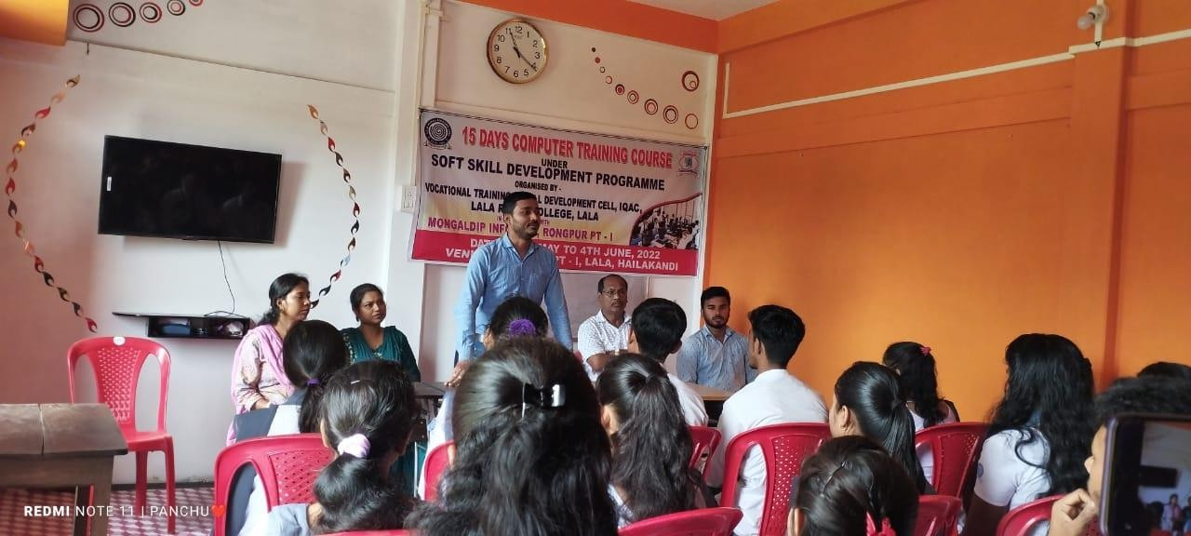

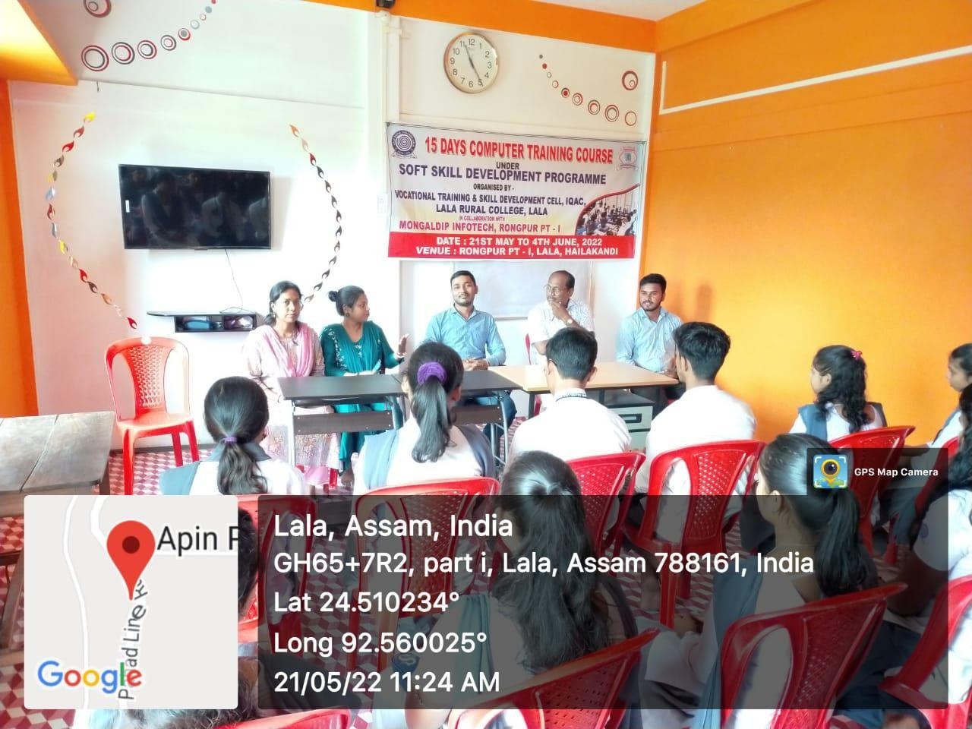

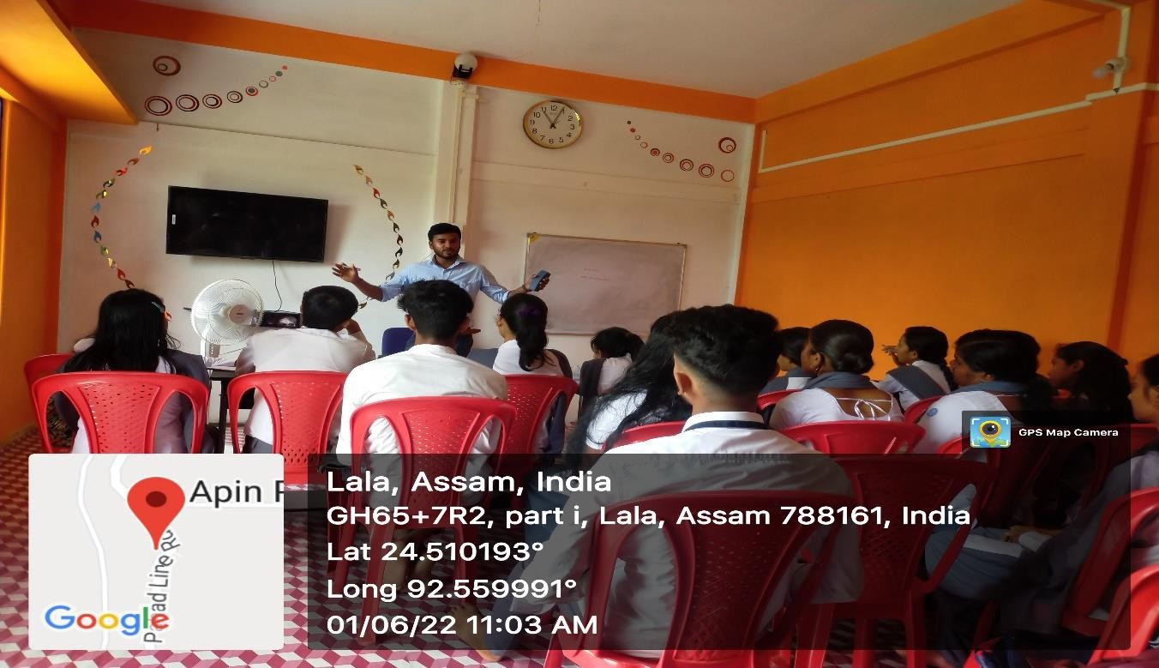

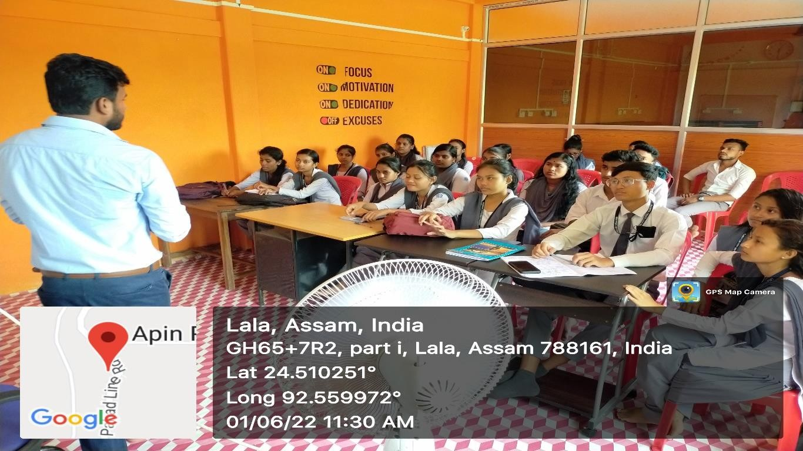

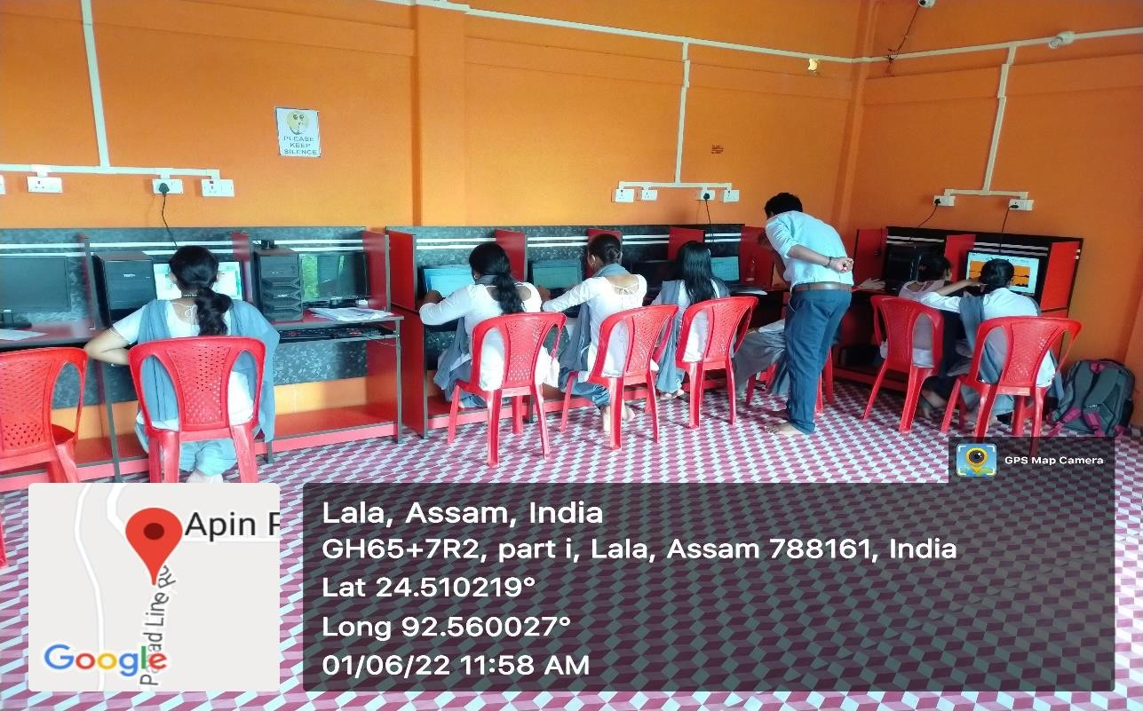

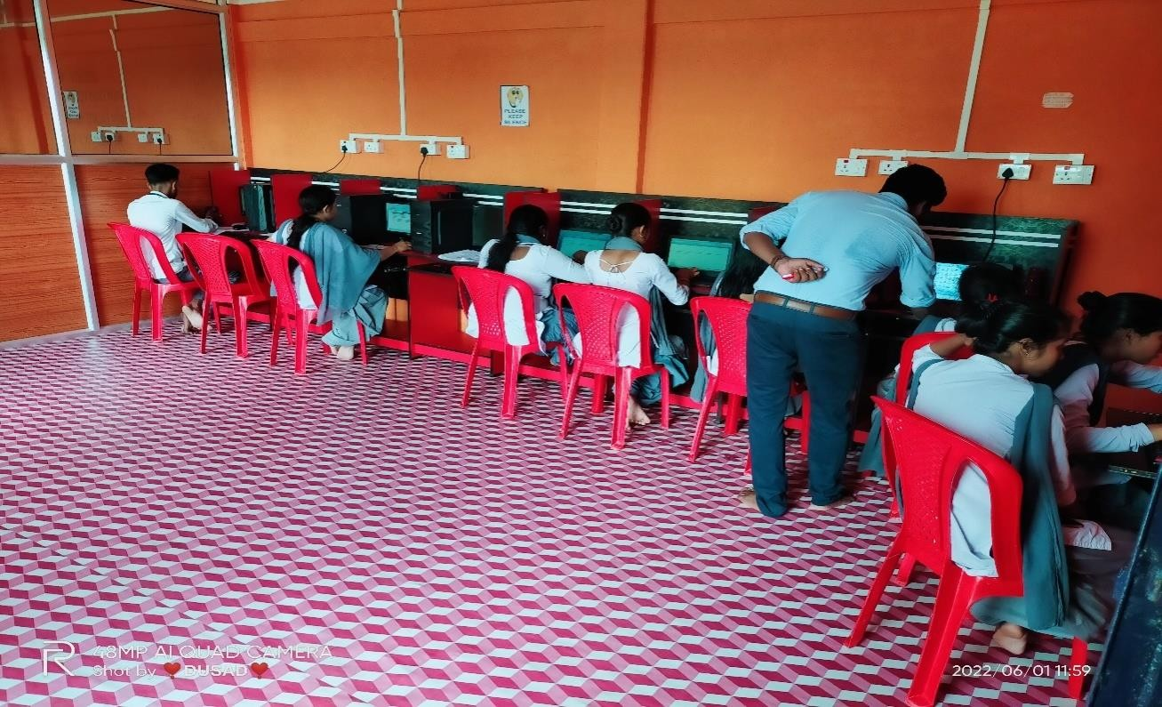

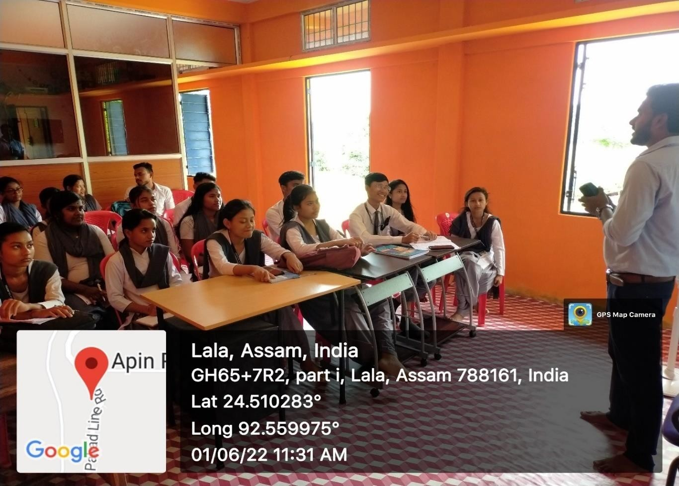

Attendance Sheet:
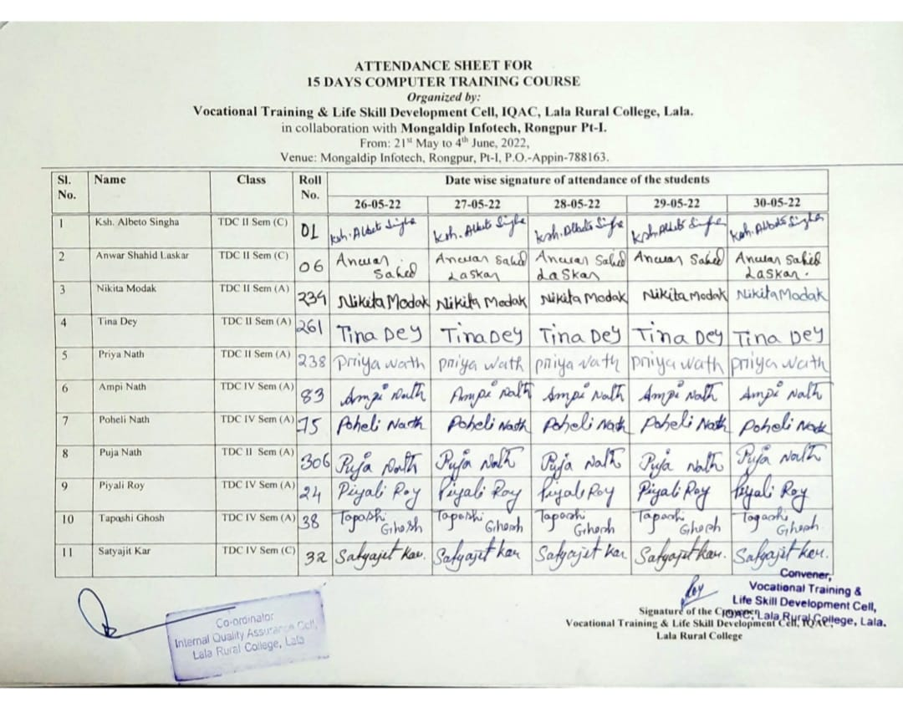

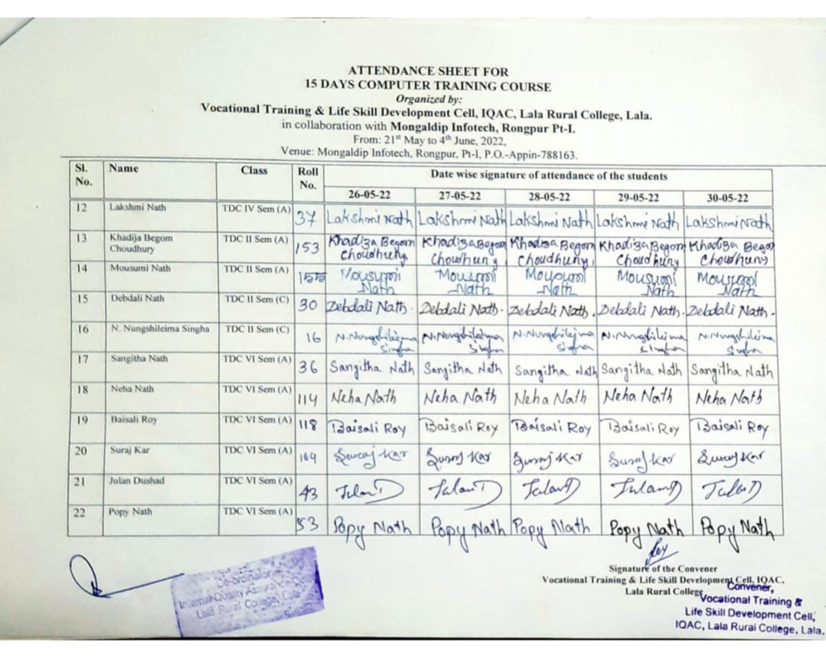
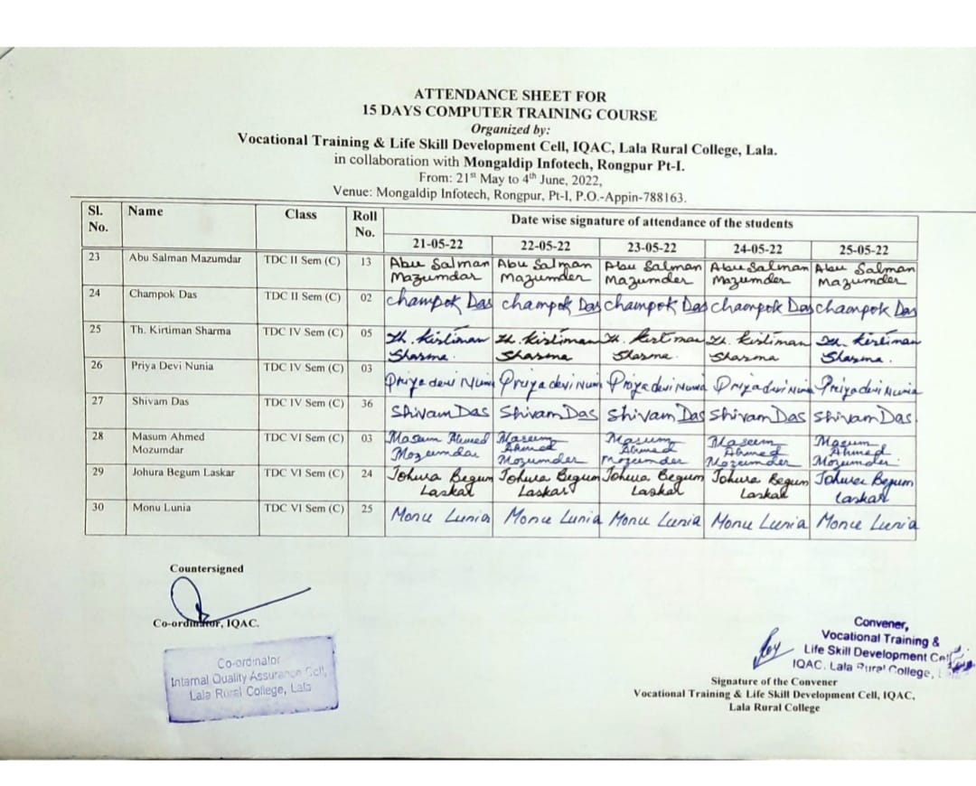

Sample Certificates:
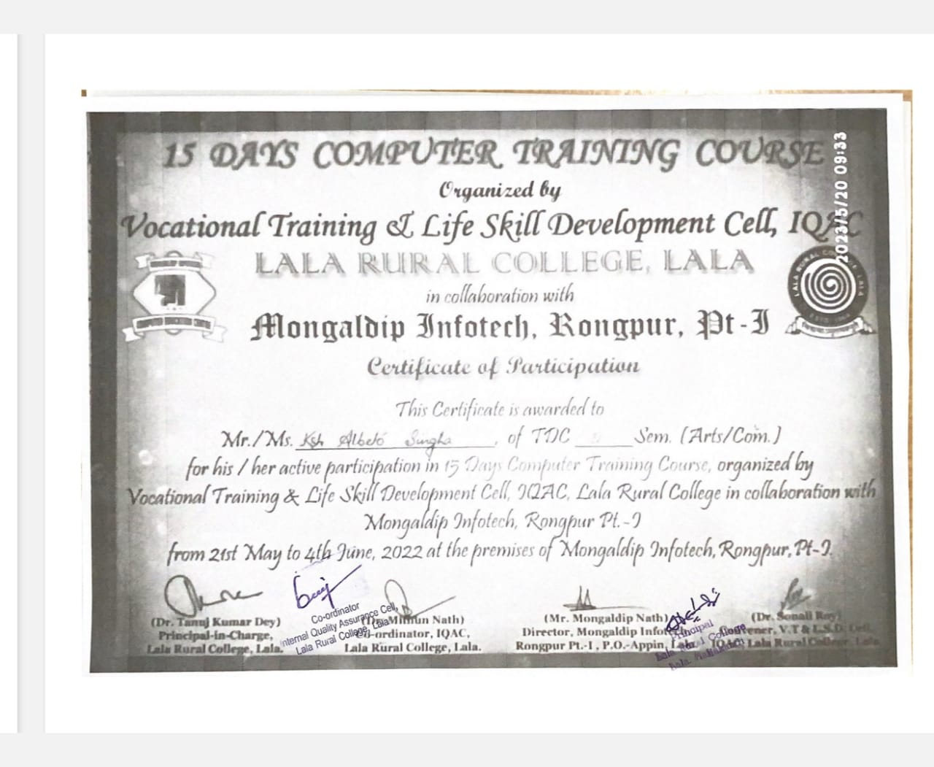

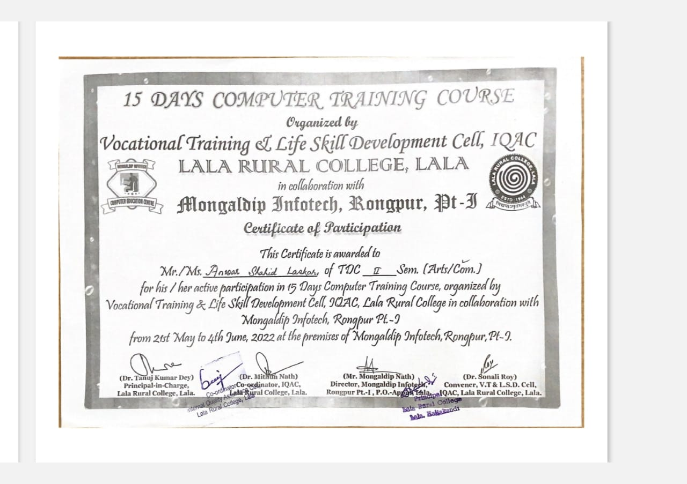
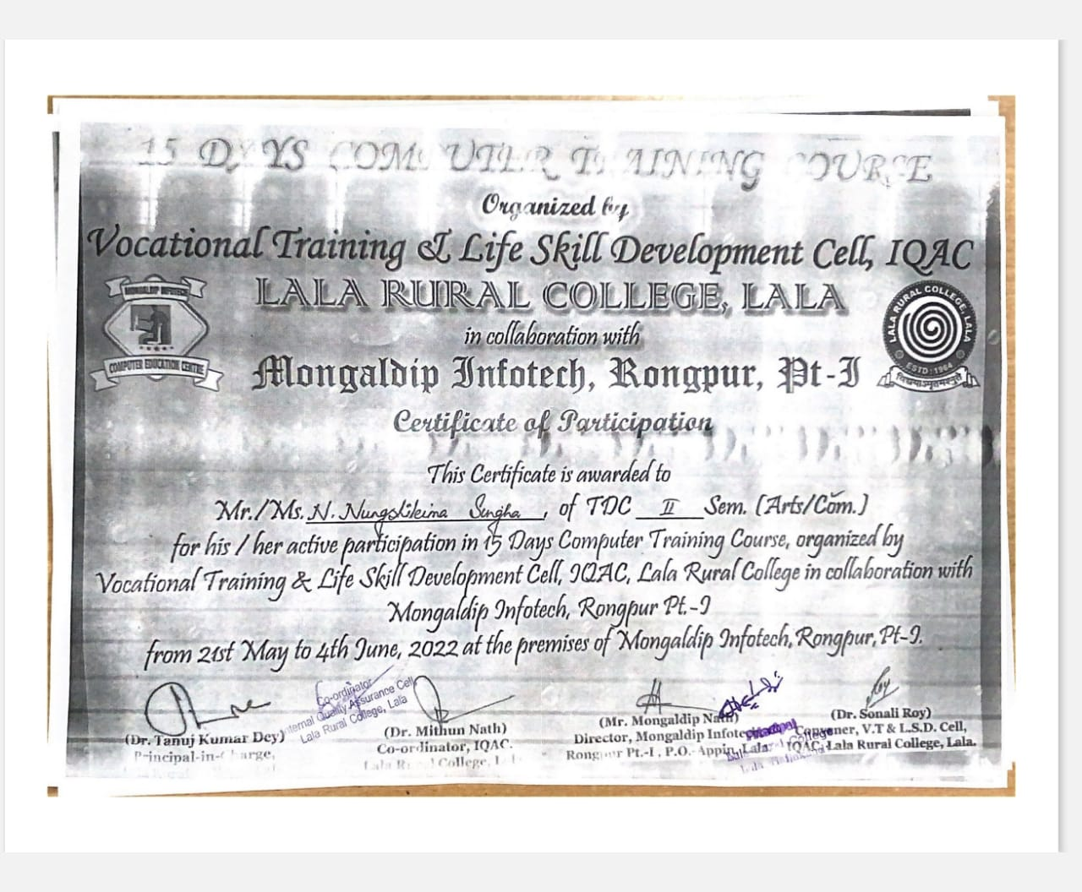

5 Days Vocational Training Programme on Cutting and Tailoring organised by Vocational Training & Life Skill Development Cell, IQAC, Lala Rural College, Lala

With a small step taken towards skill development and making the students self-sufficient this 5 Days Vocational Training Programme on Cutting and Tailoring was organised by Vocational Training & Life Skill Development Cell, IQAC, Lala Rural College, Lala from 27th May to 31st May, 2022 in the premises of the college.
Inauguration of the programme was held on 27th May, 2022 at Old Library Building of the college and the inaugural session began at 11.00 a.m. with the welcome address by Dr. Sonali Roy, Convenor, Vocational Training & Life Skill Development Cell, IQAC, followed by the inaugural speech by Dr. Ng. Dayamoy Singha, HoD, Department of History. He emphasized on the significance of skill development and how necessary it is for every student to earn their livelihood independently.
The course was a meticulously designed tailoring course for beginners. Ms. Moonmoon Kangsabanik was hired as the instructor for the programme with arrangement of one stitching machine. The instructor was chosen based on her experience, qualification and her self- motivation to teach students. A total of 22 students, both from Arts and Commerce Stream, participated in the programme. In this course the basics of tailoring, which included how to take measurement, how to choose the right fabrics, and how to cut and sew a basic garment like blouse and kurti was taught. On the last day of the programme the students exhibited their skill of stitching, whatever they have learned from this vocational training programme and were also given participation certificates.
The valedictory session started from 2.30 p.m on 31st May, 2022 with the speech of Dr. Tanuj Kumar Dey, Principal i/c. The speech elucidated on the importance of imparting employability skills along with the process of holistic development of the students. The programme wrapped up around 4:30 p.m. with the vote of thanks from the Convener. The college authority had given tremendous support and co-ordination in making this event successful.

Enclosures:
- Programme Schedule
- List of Participants Dr. Sonali Roy, Convener,
- Photographs Vocational Training and Life
- Attendance Sheet Skill Development Cell, IQAC
- Sample Certificates

Programme Schedule:

DAY 1: 27th MAY,2022
11.00 a.m to 11.15 a.m | Inaugural Session
11.30 a.m to 11.45 a.m | Tea Break
11.45 p.m to 2.00 p.m | Theory on Cutting & Tailoring
2.00 p.m to 2.30 p.m | Lunch Break
2.30 p.m to 4.30 p.m | Theory on Measurement: Rules & Practices

DAY 2: 28th MAY,2022
11.00 a.m to 1.00 p.m. | Practical on Measurement
1.00 p.m to 2.00 p.m | Introduction to Sewing Machine
2.00 p.m to 2.30 p.m | Lunch Break
2.30 p.m to 4.30 p.m | Practical on Use of Sewing Machine

DAY 4: 30th MAY,2022
11.00 a.m to 1.00 p.m | Stitching Skills: - - Knowledge about: - Seams, Darts, Tucks, flares, plackets, pockets, necklines, hem, collars & cuff Pleats, Buttons  Hole, Buttons Hooks and Eye, Tich buttons
1.00 p.m to 1.30 p.m | Lunch Break
1.30 p.m to 4.30 p.m | Drafting, Fabric Cutting and Sewing Process- Marking with different measurement - Cutting the cloth as per marking, leaving margin for inlays and turnings. - Practice in stitching on paper for straight, zigzag, round etc. – Stitching of Handkerchief / Bib / Pillow cover / Blouse/Kurti/ Salwar Kameez

DAY 5: 31st MAY,2022
11.00 a.m to 2.00 p.m | Preparation of samples.
2.00 p.m to 2.30 p.m | Lunch Break
2.30 p.m to 4.30 p.m | Valedictory Session

List of Participants:

Sl. No. | Name | Class/Semester | Roll.No.
1. | KAJAREE NATH | 6thsem(C) | 14
2. | RUMPI BHAR | 6thsem(A) | 87
3. | PUJA TATOA | 6thsem(A) | 144
4. | PAPRI NATH | 4thsem(A) | 36
5. | H-ESHITA SINGHA | 4thsem(A) | 25
6. | BABLI NATH | 6thsem(C) | 09
7. | RATNASREE NATH | 6thsem(A) | 80
8. | ANKITA NATH | 2ndSem(A) | 08
9. | SUPARNA ROY | 4thsem(C) | 14
10. | PAYEL MAHANTA | 4thsem(A) | 123
11. | SABANA DILKIS KHANAM  MAZUMDAR | 4thsem(A) | 39
12. | ANJITA DAS | 6thsem(C) | 19
13. | RUPALI MAL | 6thsem(C) | 20
14. | L. PRIYA CHANU | 4thsem(A) | 68
15. | Y. MAGHA DEVI | 4thsem(A) | 28
16. | PALLABI NATH | 4thsem(A) | 98
17. | SHRABANI NATH | 6thsem(A) | 34
18. | SUNALI SINGHA | 6thsem(A) | 15
19. | N. NAMITA SINGHA | 6thsem(A) | 35
20. | MUSINA AMIN LASKAR | 4thsem(A) | 32
21. | YEASMIN SULTANA  LASKAR | 4thsem(A) | 126
22. | SALMA BEGOM ANSARY | 6thsem(A) | 07

Photographs:
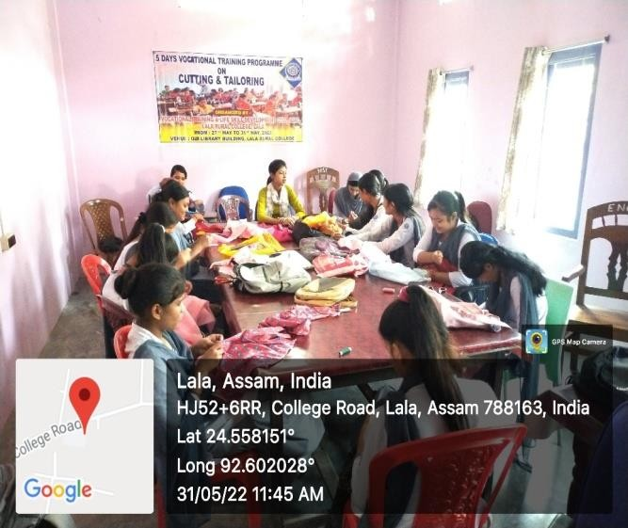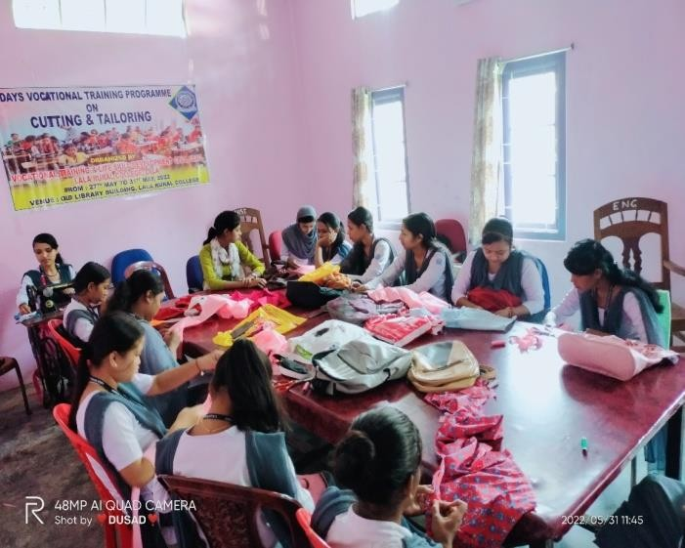

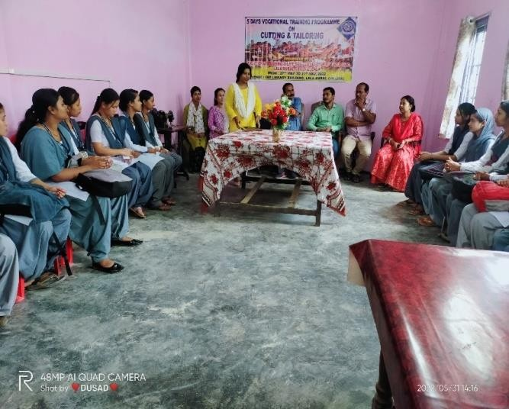
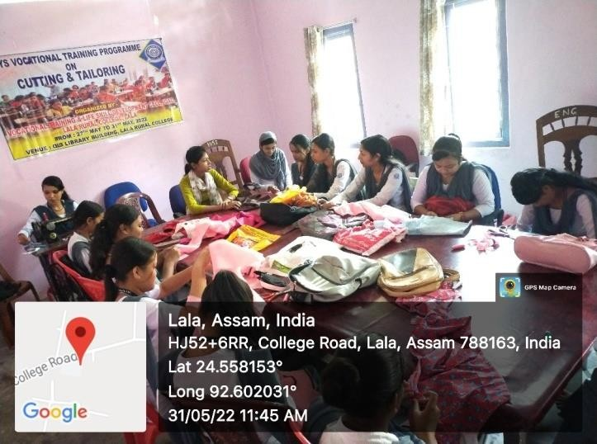
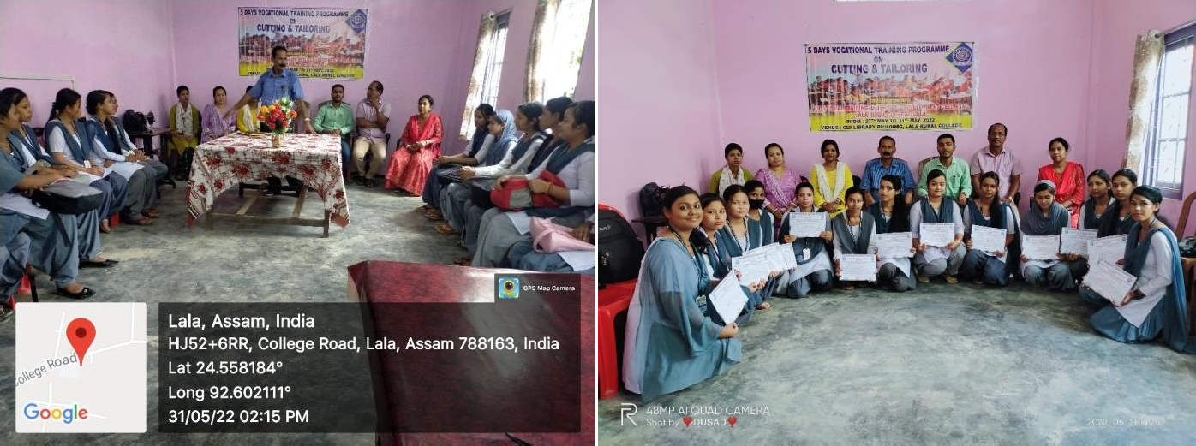
Attendance Sheet:

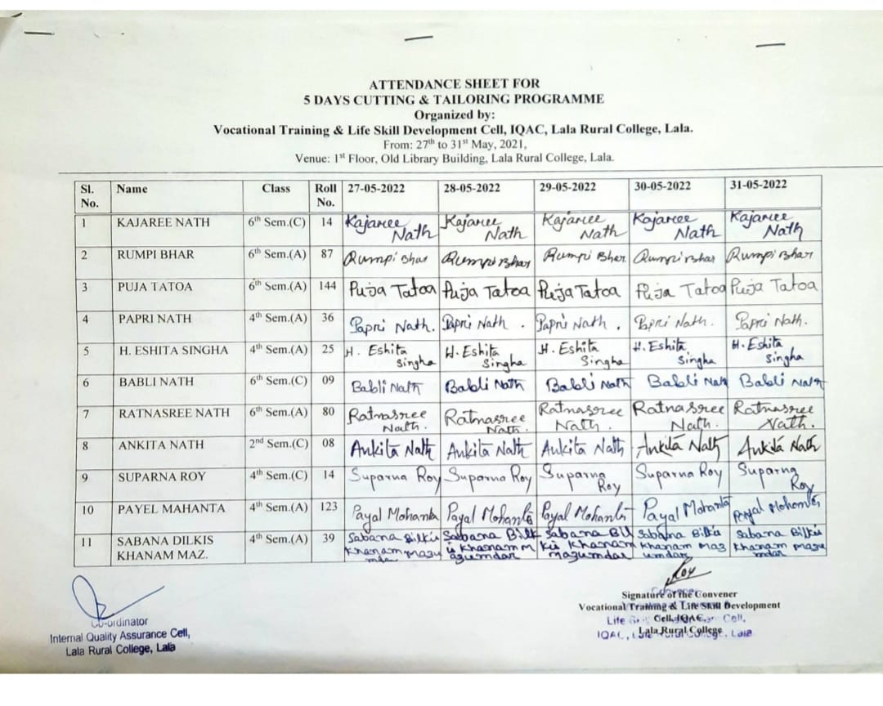

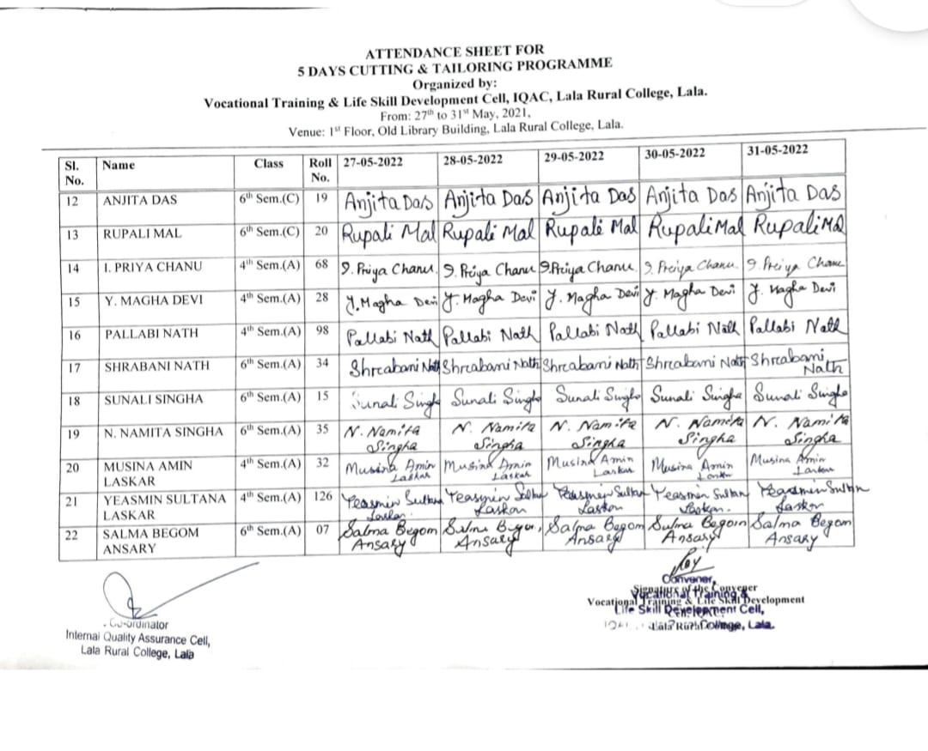
Sample Certificates:
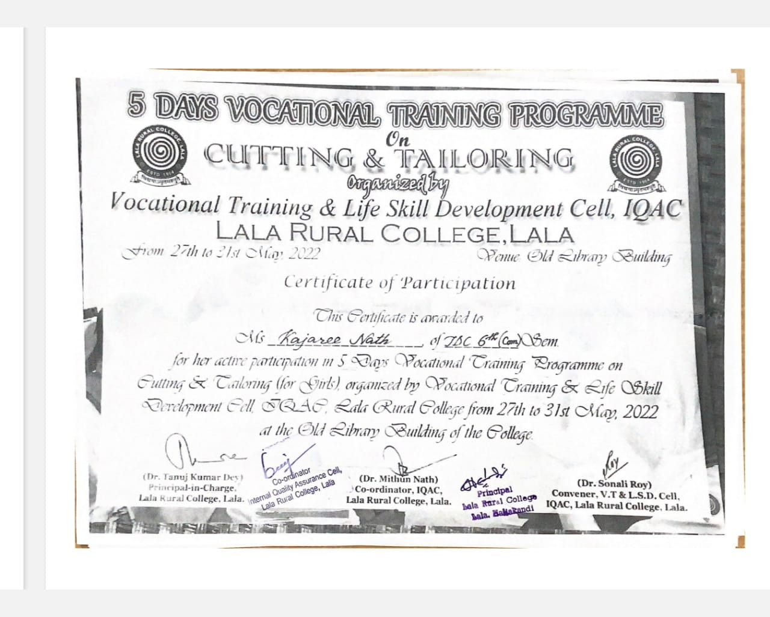

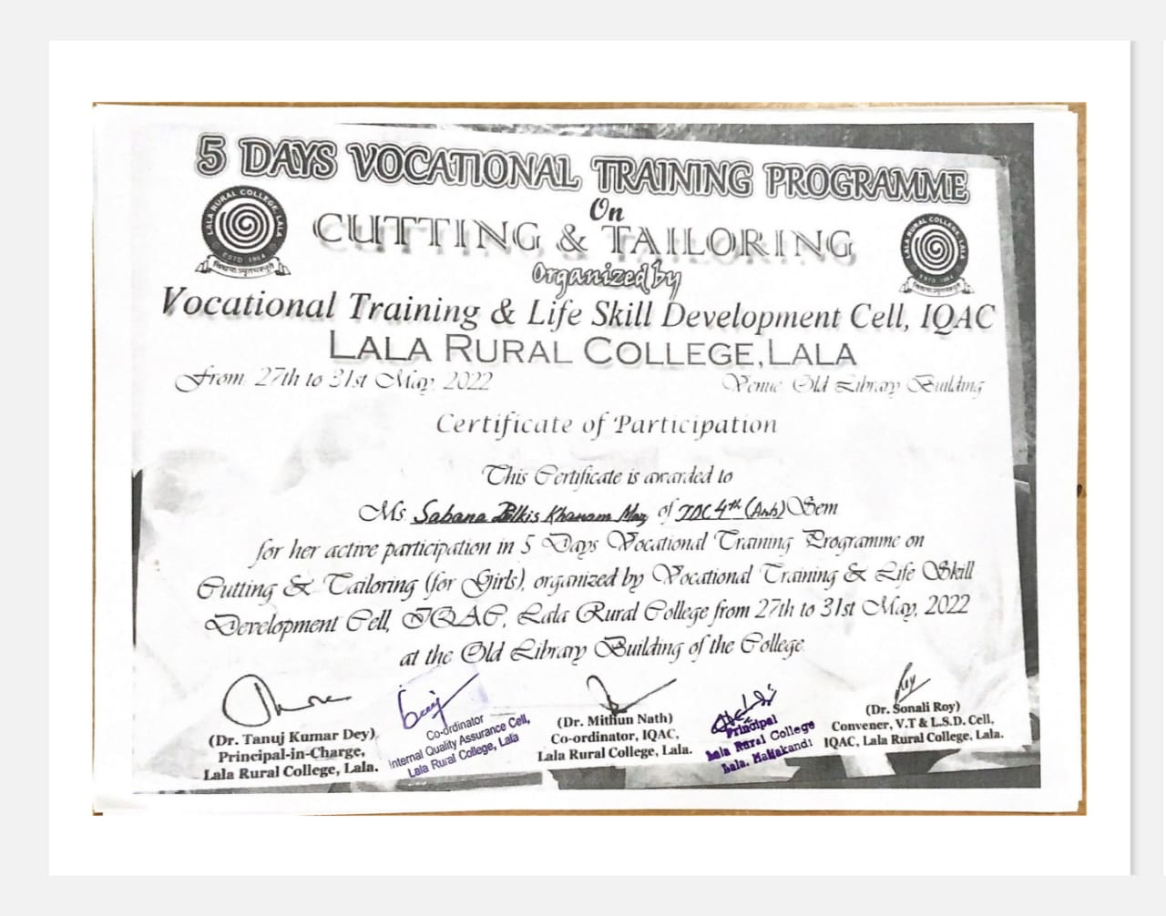
Session: 2022-2023
The activities of Vocational Training and Life Skill Development Cell for the session 2022-2023 are as follows:

Report on the IBM Skills Build Orientation Workshop
The IBM Skills Build Orientation Workshop was organized by the Vocational Training and Life Skill Development Cell, IQAC, Lala Rural College in collaboration with the District Employment Exchange of Hailakandi on 16th March, 2023. The workshop aimed to provide students with valuable insights into the world of technology, enhance their employability skills, and equip them with the knowledge and resources required to thrive in the digital era.
The workshop began at 2.30 p.m and was attended by Principal and faculty members of the college, representatives from IBM, officials from the District Employment Exchange, and enthusiastic students. A warm welcome address and a brief introduction to the objectives and agenda of the programme was delivered by the Principal of the college, Dr. Himabrata Chakravarty. A representative from IBM named Mr. Shubham Naskar delivered an inspiring keynote address, emphasizing the importance of digital skills in today's job market. He highlighted the role of IBM Skills Build in bridging the digital skills gap and creating employment opportunities.
The workshop featured a rapid overview of key digital skills and technologies, including Psychometric Analysis, In Module Assessments, Artificial Intelligence, Cloud Computing, Cybersecurity, Web Development, and Digital Marketing. Each topic was presented in a snapshot format to generate interest and curiosity among the participants. An official from the District Employment Exchange named Mr. Samujjal Das provided a brief insight into the career opportunities associated with the showcased skills. He offered insights into current job trends and the industries where these skills are in high demand. A short Q&A session allowed participants to seek clarification and engage in a brief discussion about the workshop content and related career prospects.
The workshop concluded with closing remarks from Mr. Shubham Naskar, emphasizing the importance of continuous learning and self-improvement in the digital age. Participants were encouraged to explore IBM Skills Build and similar programmes. The two-hour IBM Skills Build Orientation Workshop held at Lala Rural College Hailakandi, effectively introduced students to the world of digital skills and career opportunities. Despite its brevity, the workshop provided valuable insights into the significance of acquiring digital skills and the potential career pathways they open. The collaboration between the Vocational Training and Life Skill Development Cell and the District Employment Exchange was instrumental in bringing this informative session to students.
We extend our gratitude to CSRBOX of IBM and District Employment Exchange, Hailakandi for choosing Lala Rural College for the said workshop.

Enclosures:
- Photographs
Dr. Sonali Roy, Convener,
Vocational Training & Life Skill
Development Cell, IQAC

Photographs:

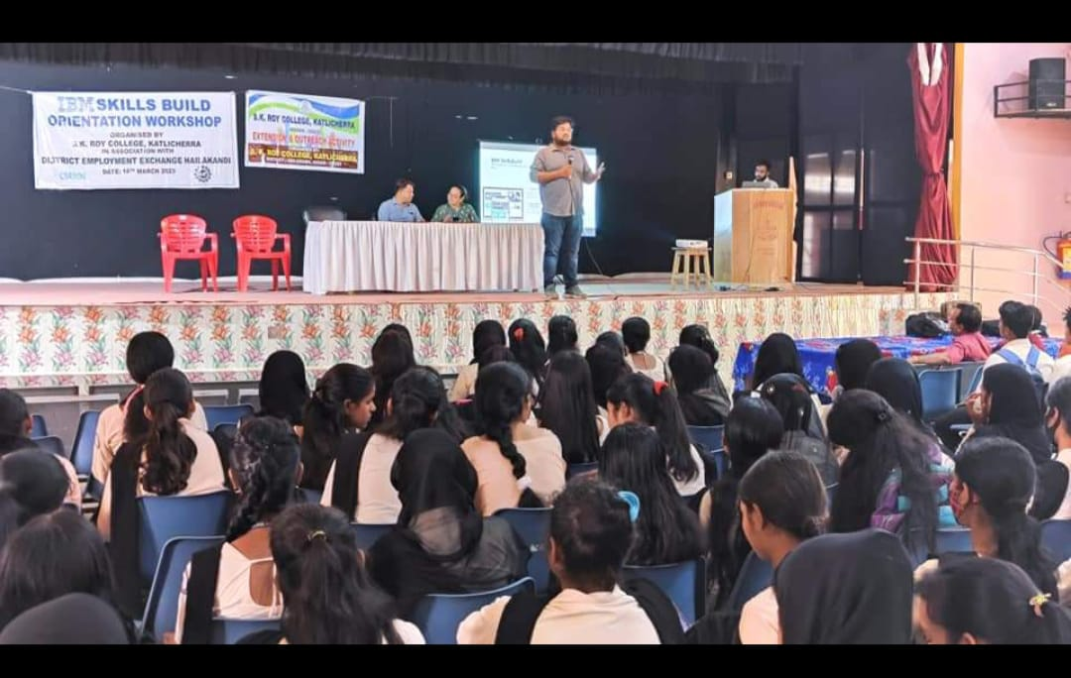

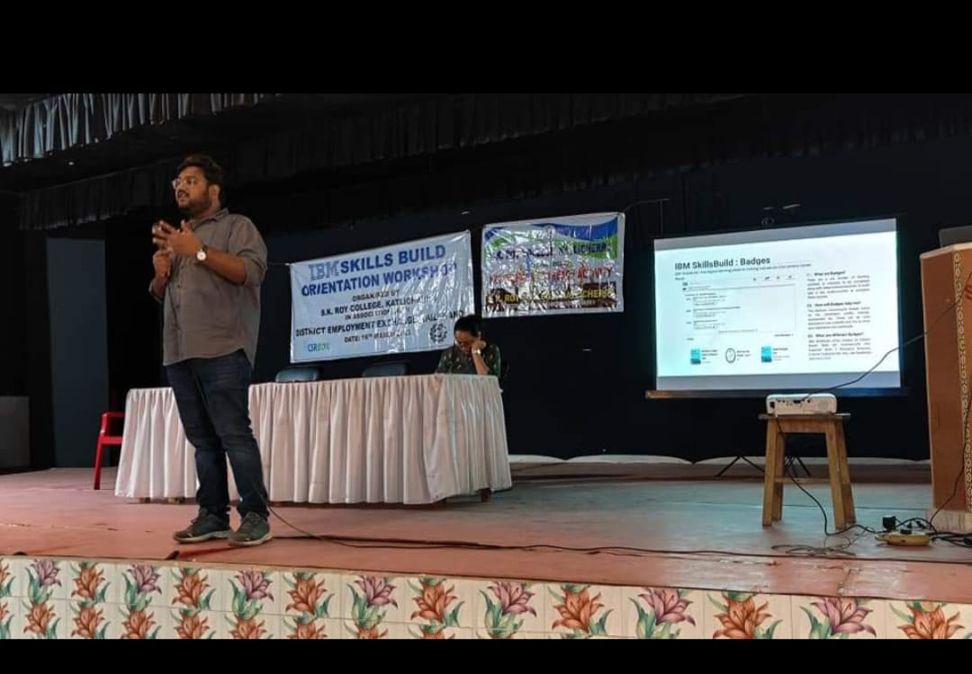
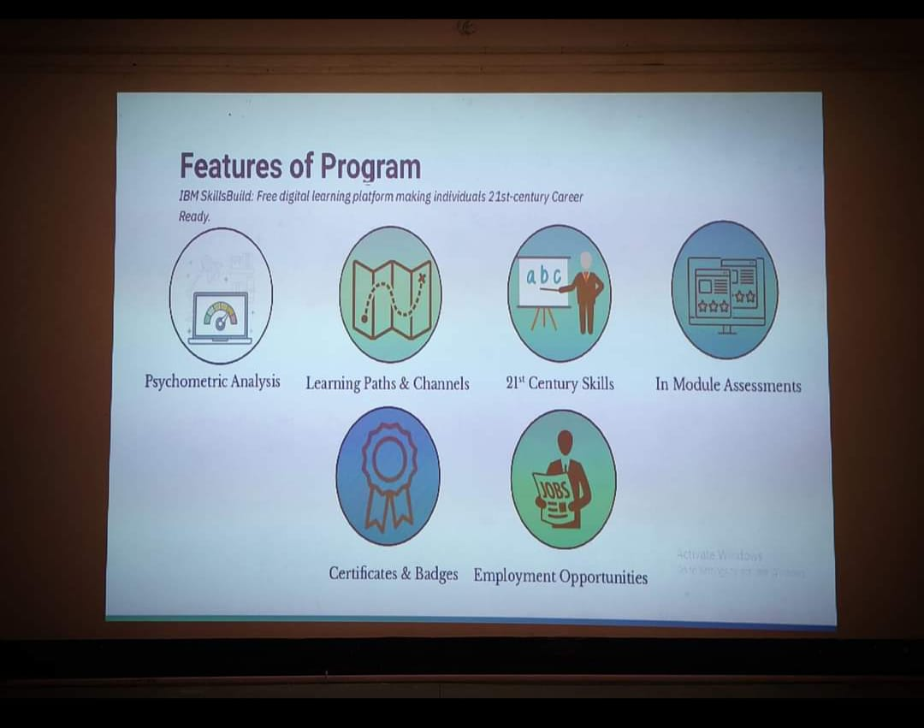

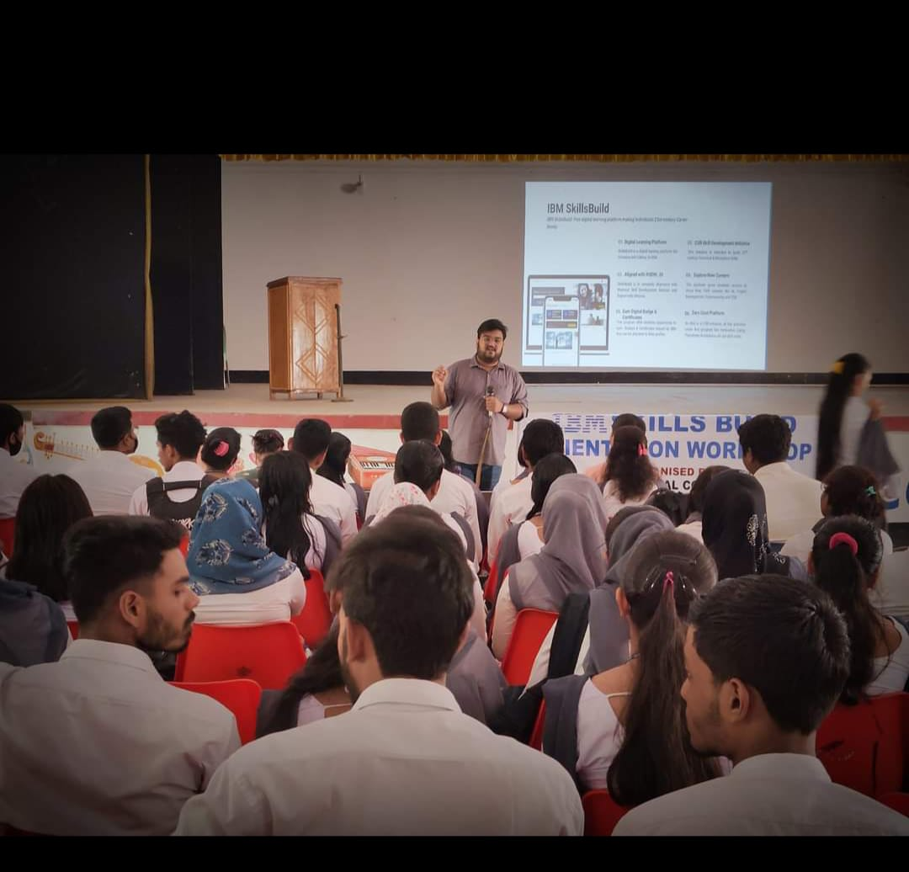
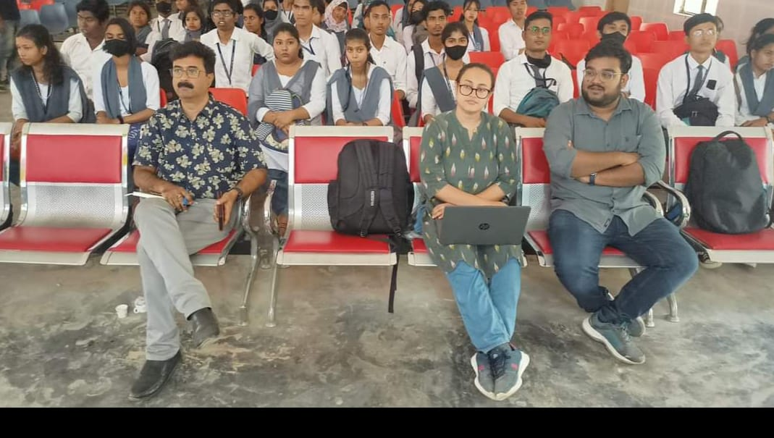

An Orientation Programme on Youth Multi-Purpose Coop: Societies & Employment Generation
The Assistant Registrar of Cooperative Societies, Hailakandi, organized a one-day Orientation Programme on Youth Multi-Purpose Coop: Societies & Employment Generation on 06th April, 2023 for the undergraduate students in collaboration with Vocational Training & Life Skill Development Cell and Career Counseling Cell, IQAC, Lala Rural College. The programme commenced with a welcome note delivered by Mrs. Deepmala Paul, Convener, Career Counseling Cell, at around 11.30 a.m. at Auditorium Hall. This was followed by an inaugural speech by Dr. Himabrata Chakrabarty, Principal, Lala Rural College.
In his introductory speech he welcomed the resource persons and the student participants. He enlightened the students and motivated them to acquire professional skills and knowledge to avail themselves of employment opportunities and utilize the platform provided by Assam Co-operative Societies.
A Panel of two members Mr. Hizbur Rahaman, Auditor Co-operative Societies, and Mr. Mihir Kanti Paul, Auditor Co-operative Societies were approached as the resource persons from the office of Assistant Registrar of Cooperative Societies, Hailakandi, who made the students aware of the employment generation schemes provided by Assam Co-operative Societies. Mr. Mihir Kanti Paul was felicitated by Dr. Sonali Roy, Convener, Vocational Training & Life Skill Development Cell whereas Mrs. K. Dipika Singha, Member, Career Counseling Cell felicitated Mr. Hizbur Rahaman with Assamese Gamocha as a token of appreciation and respect.
Mr. Hizbur Rahaman initiated the technical session at around 12 p.m. where the students were informed about the newly introduced scheme by Registrar of Cooperative Societies, Assam. Under this scheme, students have an opportunity to form a co-operative group of 10 members or more and come up with a business proposal where the organization will lend them all amenities including the seed money.
Later on, Mr. Mihir Kanti Paul explained in detail regarding the process of registration, formalities and initial amount required to start the business. He also attended all the queries raised by the students in respect of formation of co-operative groups.
Around 179 students and 27 staff members participated in the programme, out of which 20 numbers of students confirmed their interest to grab the prevailing opportunity. In this regard, Mr. Alok Regon, Assistant Professor, Department of Economics, was appointed as the nodal teacher to guide and mentor the interested students.
The overall response and feedback of the programme was positive as the objective of the organization to search for adequate number of students to initiate startup business and to generate employment opportunities was fulfilled. The programme ended at around 2.30 p.m. with a vote of thanks delivered by Dr. Ng. Dayamaya Singha, Co-ordinator, IQAC.

Submitted and Compiled by

Dr. Sonali Roy Mrs. Deepmala Paul
Convener, Convener,
Vocational Training & Life Skill Career Counseling Cell,
Development Cell, IQAC, IQAC, Lala Rural College
Lala Rural College

Enclosures:
- Photographs
- Teachers’ and Students’ Attendance Sheets

Photographs:

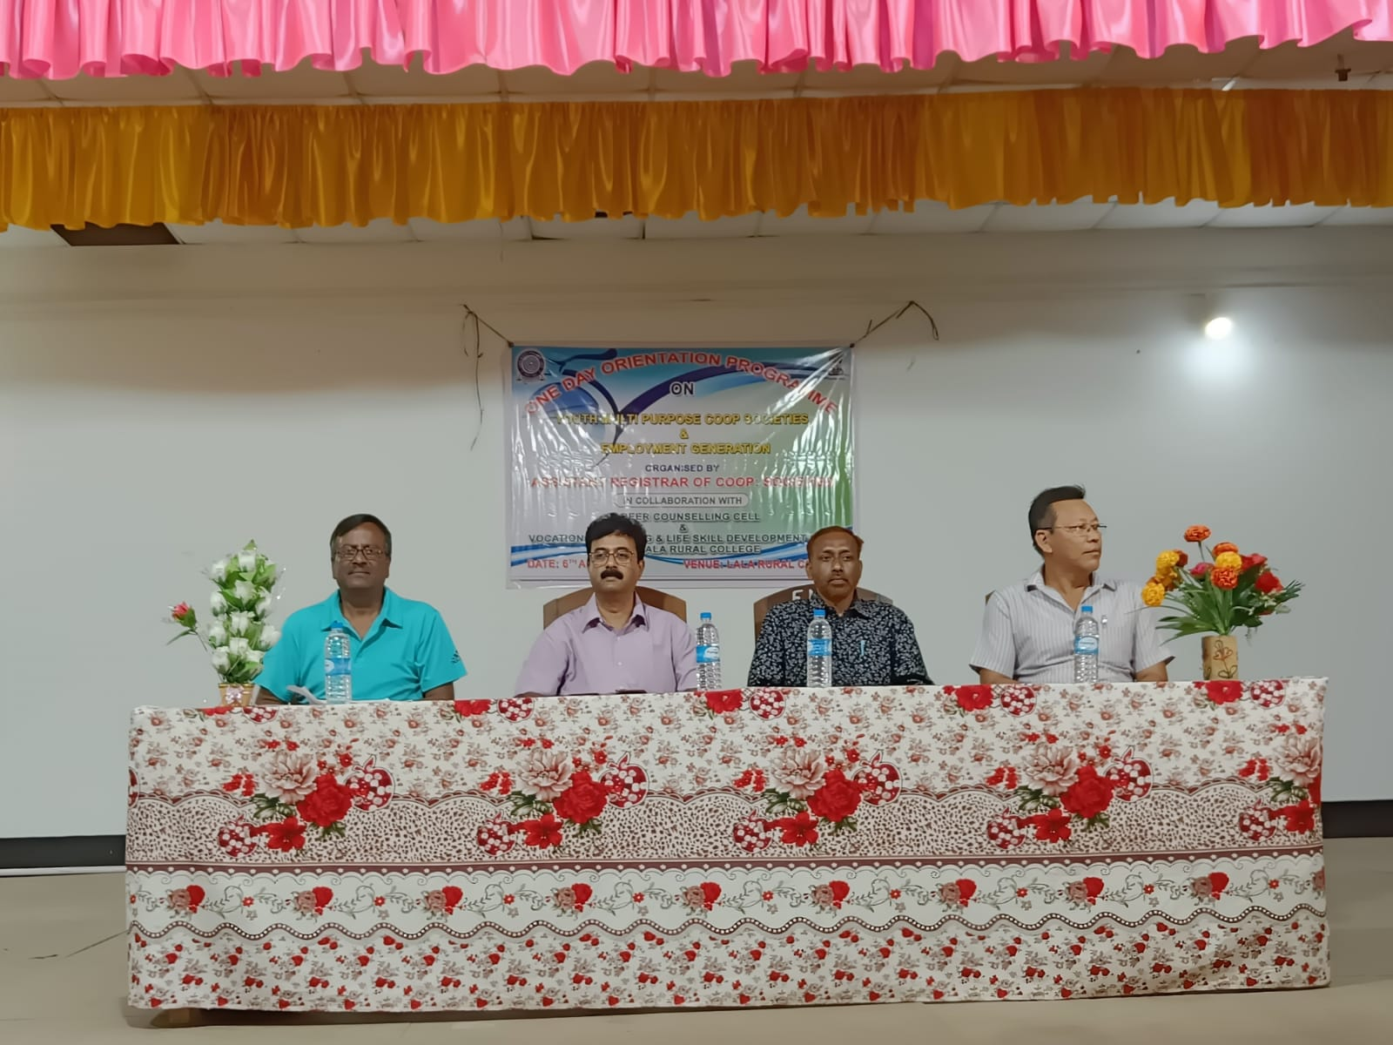

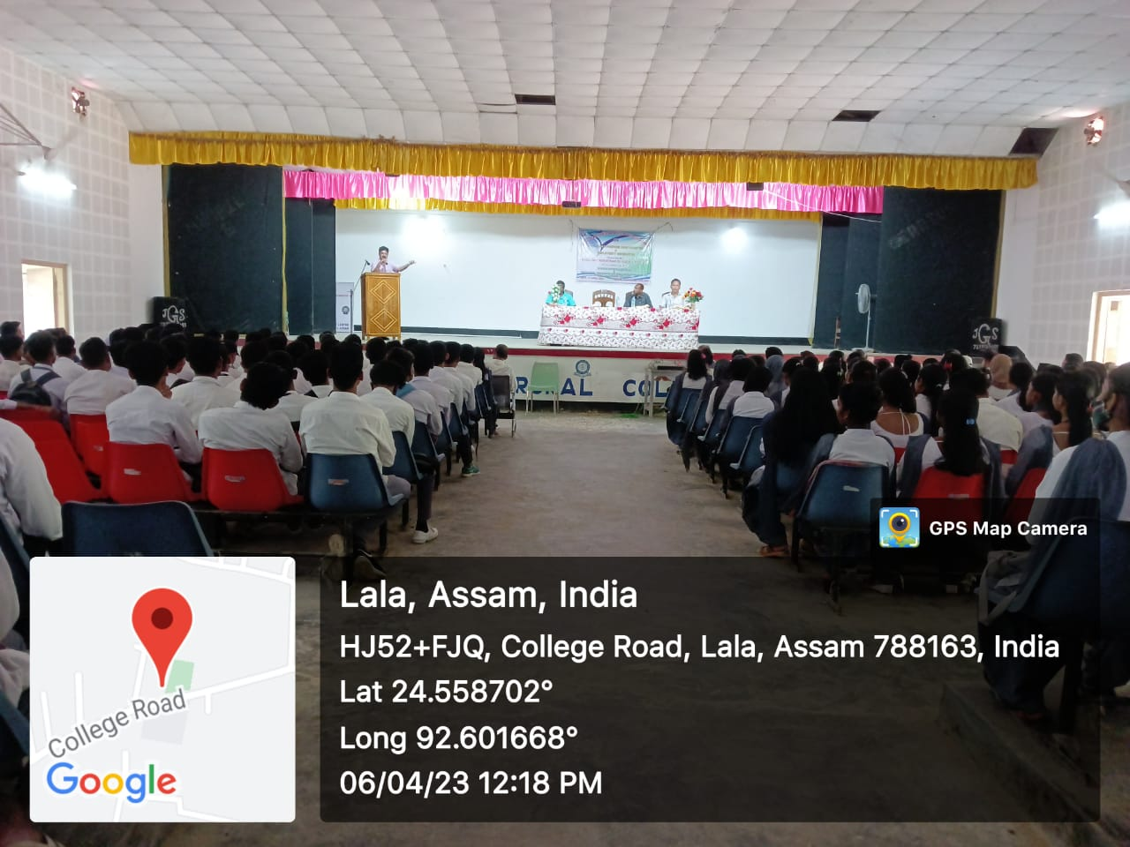
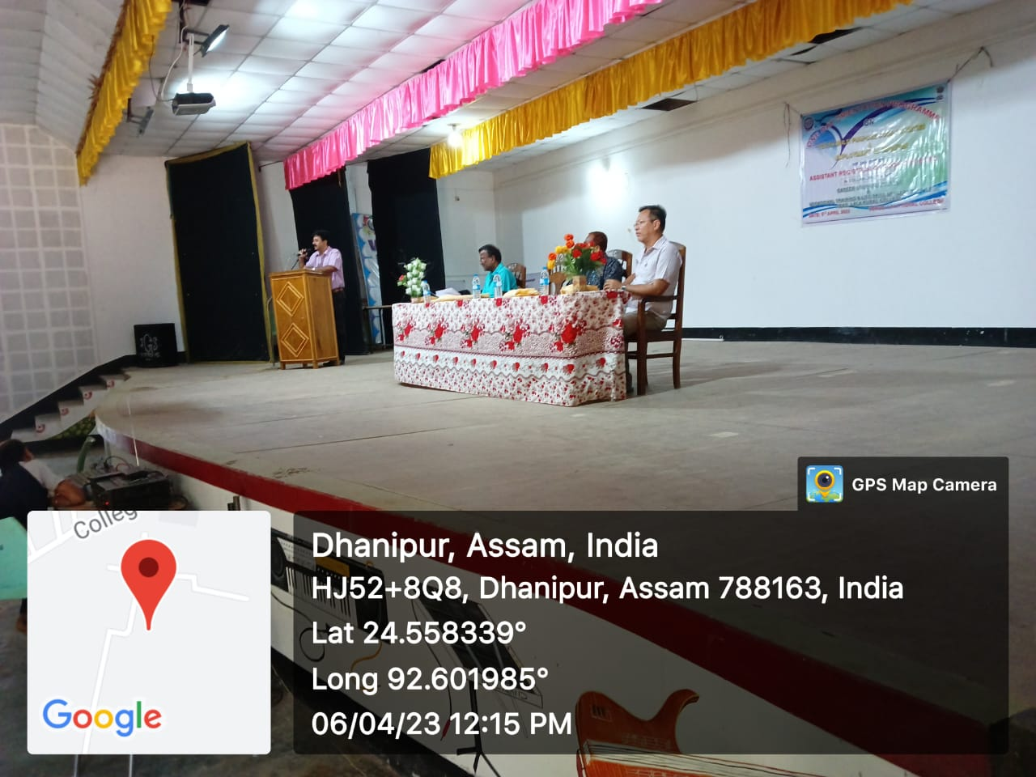

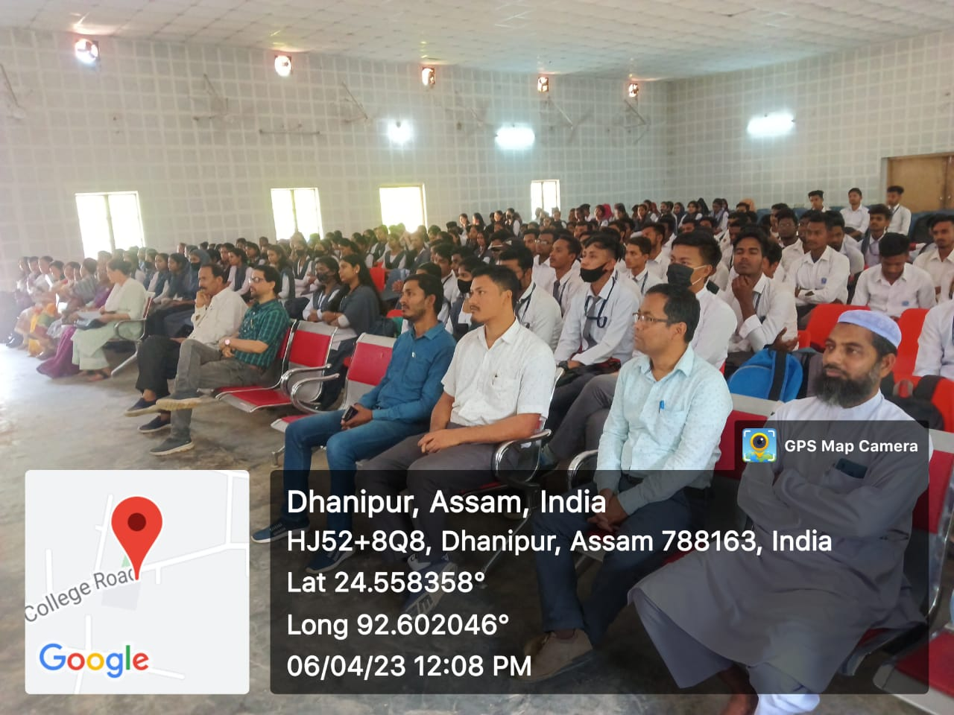

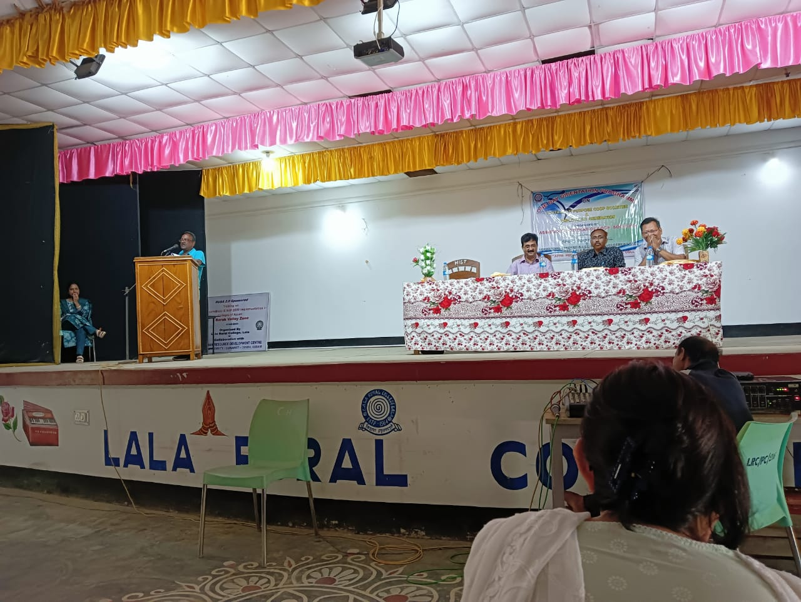

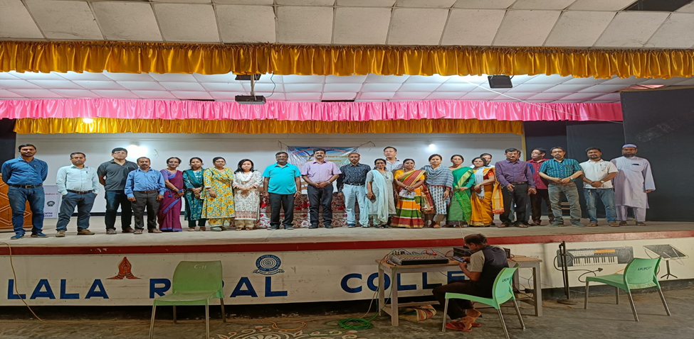

Attendance Sheets:

