Report on Activities of The Entrepreneurship (Vocational) Training and Life Skill Development Cell, IQAC, Lala Rural College
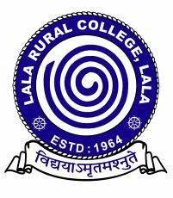
Session: 2023-2024

SESSION: 2023-2024
The reports on the programmes organized by the Entrepreneurship (Vocational) Training and Life Skill Development Cell for the session 2023-2024 are as follows:
A Programme on “Unemployment and Poverty-Free Society, Catalyzed by Entrepreneurship”
Under Swavalambi Bharat Abhiyan
Organized By:
The Entrepreneurship (Vocational) Training and Life Skill Development Cell and Career Counseling Cell, IQAC, Lala Rural College in collaboration with Akhil Bharatiya Vidyarthi Parishad (ABVP)
Date: 4th October,2023
Venue: College Auditorium
Introduction:
A programme titled "Unemployment and Poverty-Free Society, Catalyzed by Entrepreneurship" was organized under the Swavalambi Bharat Abhiyan initiative. The event was a collaboration between ABVP, the Entrepreneurship (Vocational) Training & Life Skill Development Cell, and the Career Counseling Cell of Lala Rural College. This initiative aimed to inspire students to tackle the twin issues of unemployment and poverty through entrepreneurial ventures, emphasizing self-reliance and rural development.
Objectives of the Programme:
The programme sought to:
- Address the issues of unemployment and poverty in both rural and urban settings.
- Promote entrepreneurship as a means of self-employment and community development.
- Provide students with real-world insights into successful entrepreneurial ventures.
- Inspire students to pursue entrepreneurship and skill development as viable career paths.
Participation:
The event was attended by around 200 students from both the Arts and Commerce streams, showcasing their growing interest in entrepreneurship as a career option.
Details of the Programme:
The event featured two prominent resource persons who shared their experiences and insights on how entrepreneurship can be a catalyst for socio-economic change.
Session by Mr. Bapan Das:
Mr. Bapan Das, the co-founder of ‘Graduate Farmer’, presented his entrepreneurial journey and the impactful work his startup is doing to improve rural livelihoods. Graduate Farmer, a unit of GRDT Farmers Agrovet Pvt. Ltd., is involved in:
- Producing Antibiotic-Free Chicken and Eggs: By promoting backyard poultry farming, the startup supports small-scale farmers, especially women, enabling them to rear poultry without the use of antibiotics.
- Organic Oyster Mushroom Production: Utilizing agricultural waste, Graduate Farmer produces organic mushrooms, offering an eco-friendly solution to waste management and creating an additional income source for farmers.
- Bamboo-Based Products: The startup also explores bamboo-based products, adding another dimension to rural entrepreneurship by leveraging sustainable materials.
Mr. Bapan Das inspired the students with the story of how he founded his startup Graduate Farmer and the impactful work it has been doing in promoting sustainable farming practices. He encouraged students to view entrepreneurship not just as a means to generate income but also as a way to bring about positive change in their communities. By demonstrating how his venture, focused on antibiotic-free chicken, organic mushroom farming, and bamboo-based products, helps local farmers particularly women, Mr. Das showed the students that small, local efforts can have a big impact. His emphasis on using locally available resources and promoting eco-friendly practices made the students see entrepreneurship as a path to sustainability and community welfare.
During his session, Mr. Bapan Das highlighted several avenues and government schemes that are particularly beneficial for upcoming entrepreneurs, especially those in rural areas. He emphasized the importance of utilizing these resources to overcome challenges such as funding, technical know-how, and market access. By outlining these schemes, Mr. Das provided a roadmap for students to access financial and technical support, making entrepreneurship more attainable for them.
Session by Ms. Sharna Chakraborty:
The second resource person, Ms. Sharna Chakraborty, a Mahatma Gandhi National Fellow under the Ministry of Skill Development and Entrepreneurship, addressed the critical role that skill development plays in combating unemployment and poverty. Her focus was on the development of the skill ecosystem in Hailakandi District, where she is working to enhance opportunities for youth and entrepreneurs by:
- Strengthening the skill ecosystem and connecting youth with relevant training programmes.
- Bridging the gap between education and employability by providing skills that are in demand in the job market.
- Fostering local entrepreneurship by helping individuals acquire the necessary skills to start their own businesses.
Ms. Chakraborty highlighted various government schemes and programmes that students can benefit from, particularly those focusing on skill development and entrepreneurship. She encouraged the students to take advantage of the training opportunities available in the district and to see skill development as a stepping stone to entrepreneurship.
Interactive Session and Q&A:
Following the resource persons' presentations, an engaging Q&A session was held, where students actively participated, asking insightful questions about both entrepreneurship and skill development. Mr. Das and Ms. Chakraborty answered questions related to funding opportunities, technical know-how for starting businesses, and how to access government schemes for skill development and entrepreneurship.

Outcome of the Programme:
The programme left a significant impact on the students, many of whom were inspired to consider entrepreneurship and skill development as potential career paths. The combination of real-life entrepreneurial experience shared by Mr. Bapan Das and practical guidance on skill development provided by Ms. Sharna Chakraborty gave students a comprehensive understanding of how they can contribute to and benefit from the entrepreneurial ecosystem.
Conclusion:
The event concluded with a vote of thanks, expressing gratitude to Mr. Bapan Das and Ms. Sharna Chakraborty for sharing their valuable insights and experiences. It was a resounding success, with the active participation of students from both Arts and Commerce streams. The collaborative effort of ABVP, the Entrepreneurship (Vocational) Training & Life Skill Development Cell, and the Career Counseling Cell of Lala Rural College provided students with invaluable insights into entrepreneurship and skill development. Both resource persons, Mr. Bapan Das and Ms. Sharna Chakraborty, effectively highlighted the importance of self-reliance and skill enhancement, thereby motivating students to take proactive steps toward building an unemployment and poverty-free society.

Enclosures: 
- Photographs
Dr. Sonali Roy, Convener,
Entrepreneurship (Vocational) Training & Life Skill Development Cell, IQAC, LRC

Photographs:

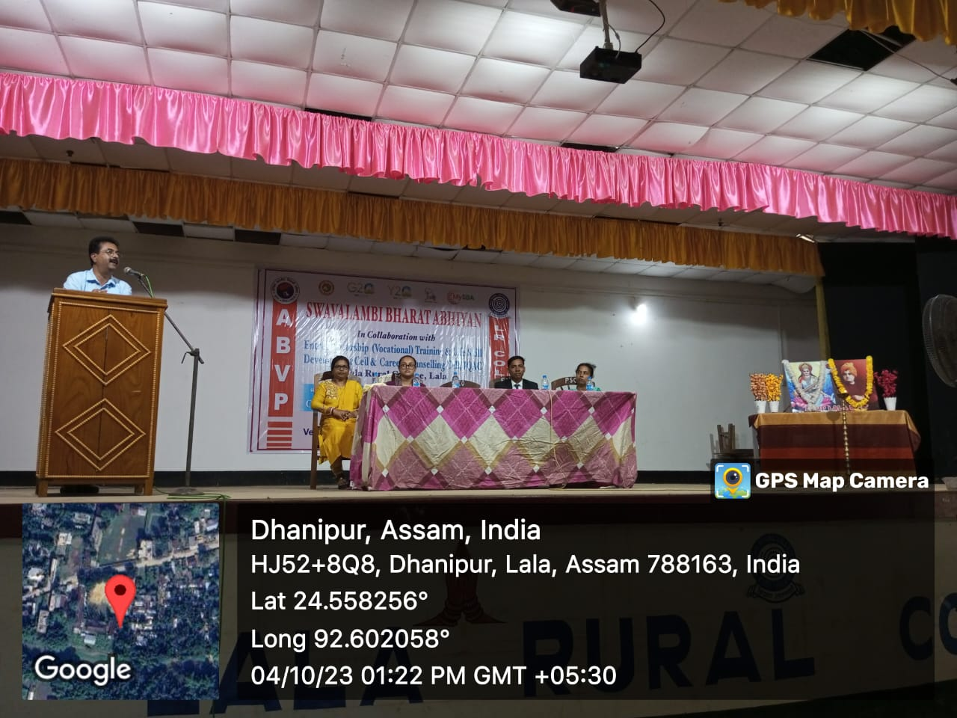

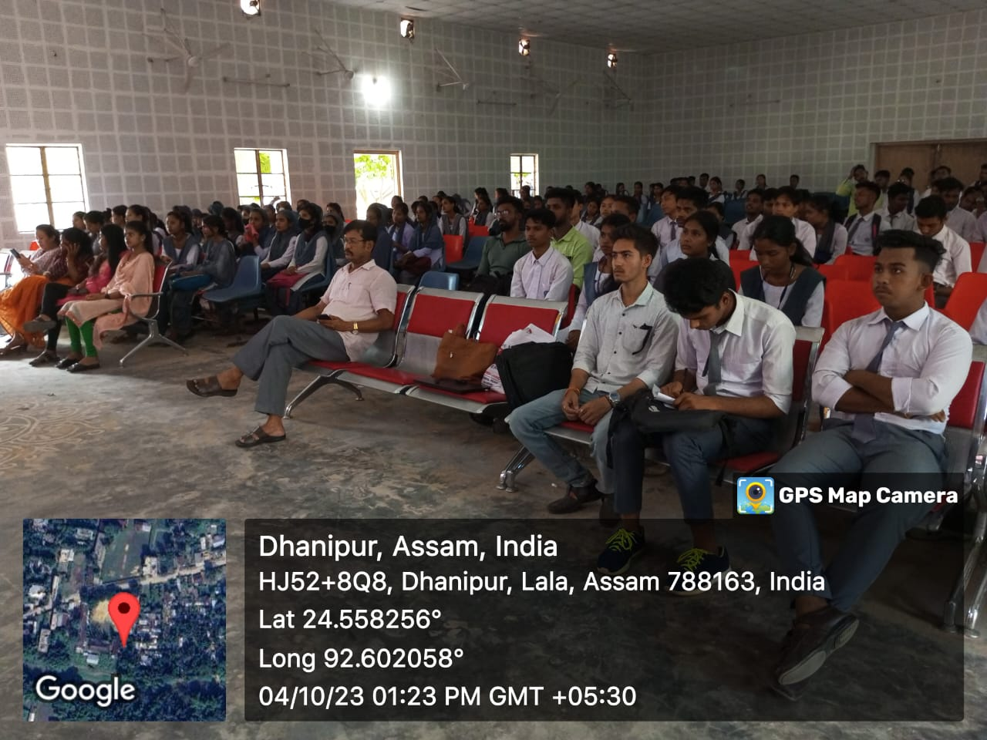

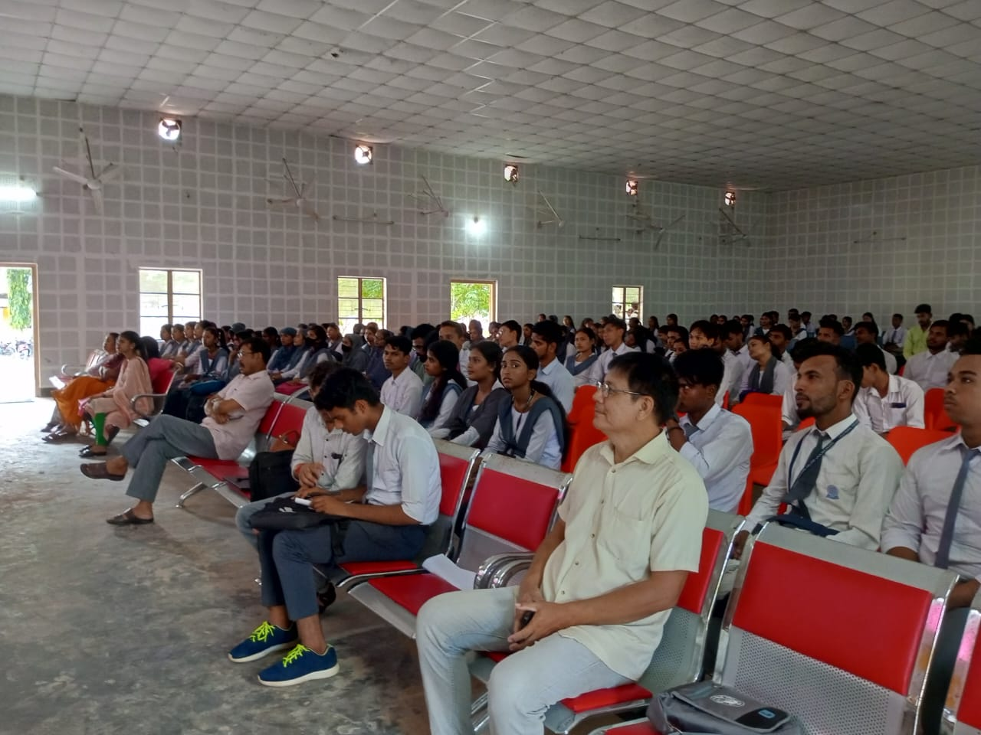

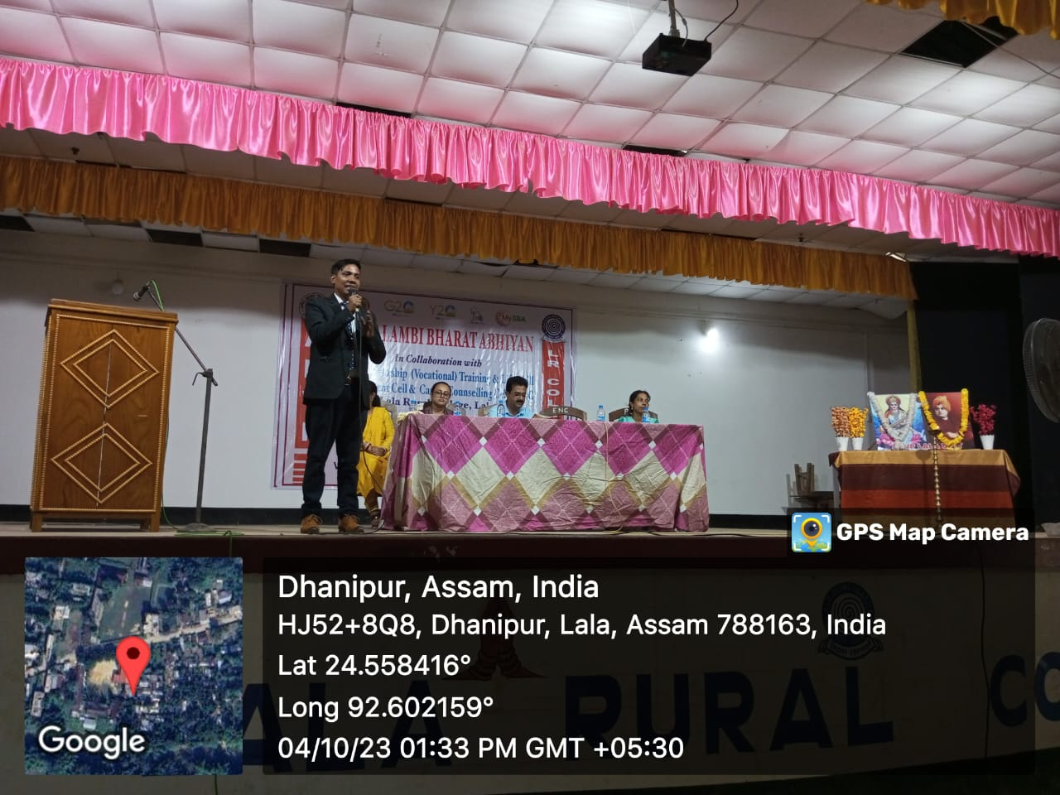

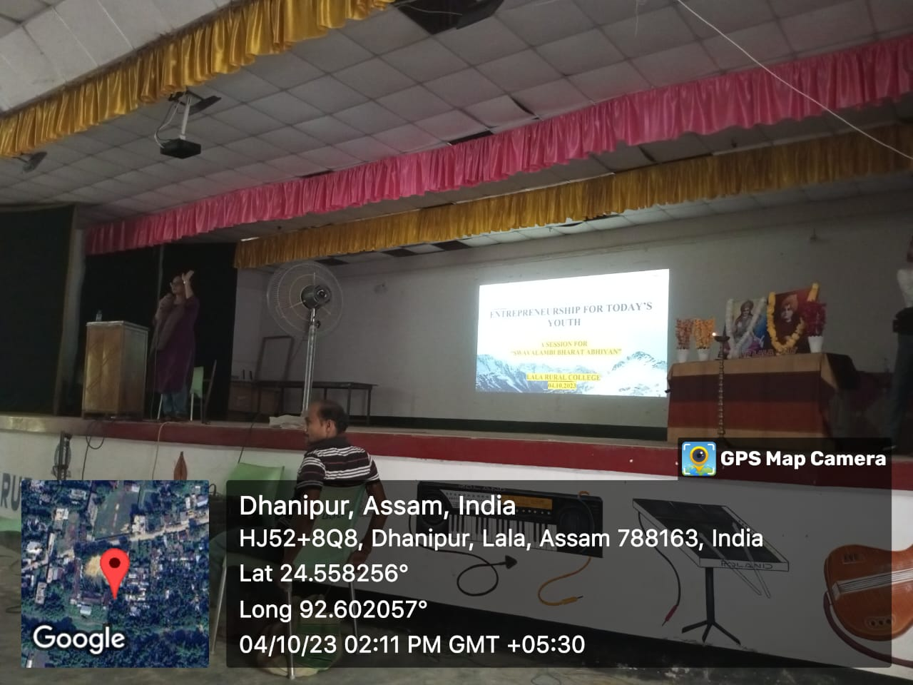

An Orientation Programme on Recruitment Drive and Free Training on Tourism & Hospitality Sector

Under Pradhan Mantri Kaushal Vikash Yojana (PMKVY) 4.0 Scheme
Organized by:
The Entrepreneurship (Vocational) Training and Life Skill Development Cell and Career Counseling Cell, IQAC, Lala Rural College in collaboration with SODEXO & Ascensive Educare Ltd. (NSDC Training Programme)
Date: 20th February, 2024
Time: 10.00 am to 2.00 pm
Venue: Auditorium, Lala Rural College

Entrepreneurship (Vocational) Training and Life Skill Development Cell and Career Counselling Cell, IQAC, Lala Rural College in collaboration with SODEXO & Ascensive Educare Ltd. (NSDC Training Programme) organised an orientation programme on 20th February,2024 for the degree students (TDC 6th Semester) of the college to develop their critical thinking abilities while dealing practical situations at the workplace. This programme was organised under Pradhan Mantri Kaushal Vikash Yojana (PMKVY) 4.0 Scheme. The prime goal of this orientation programme was to provide skill development training and creating an empowered workforce in the field of Tourism, Hospitality and Allied sectors. In this particular event, experts Mr. Abijit Dey and Viraj Roy were invited from Ascensive Educare Ltd. (NSDC Training Partner), Hailakandi to enlighten our students regarding the importance of undergoing the upcoming three months job-training course to get employment in Hospitality and Allied Sectors. This organisation offers various certified diploma courses to students from various background to build up their competence and professionalism. The three months training programme that they are going to provide is entirely free of cost for the college students. Additionally, students undergoing the upcoming training programme will get a stipend of Rs. 500/- every month until the completion of the course. The whole expenditure to be incurred for arranging the programme will be funded by the Central Government under the flagship scheme of PMKVY. The objective of this Skill Certification Scheme is to enable Indian youths to take up industry relevant skill training that will help them in securing a better livelihood.
With response to our invitation, a total number of 180 students attended and showed interest to register themselves for the upcoming programme. Both of the experts delivered an extended introductory speech and enlightened the students on the concept in a simplified way. They also encountered a brief discussion with the audience present there to clear all doubts regarding course curriculum of the programme. At the concluding part, a total of 35 number of students were screened for the first session of the three months training programme.
The entire programme was conducted by Dr. Sonali Roy, Convener, Entrepreneurship (Vocational) and Life Skill Development Cell and concluded with a vote of thanks delivered by Mrs. Deepmala Paul, Convener, Career Counselling Cell. The support and strength that came from Principal and Co-ordinator, IQAC, is highly appreciable.

Enclosures: 
- Photographs Dr. Sonali Roy, Convener,
Entrepreneurship (Vocational) Training
& Life Skill Development Cell, IQAC, LRC

Photographs:
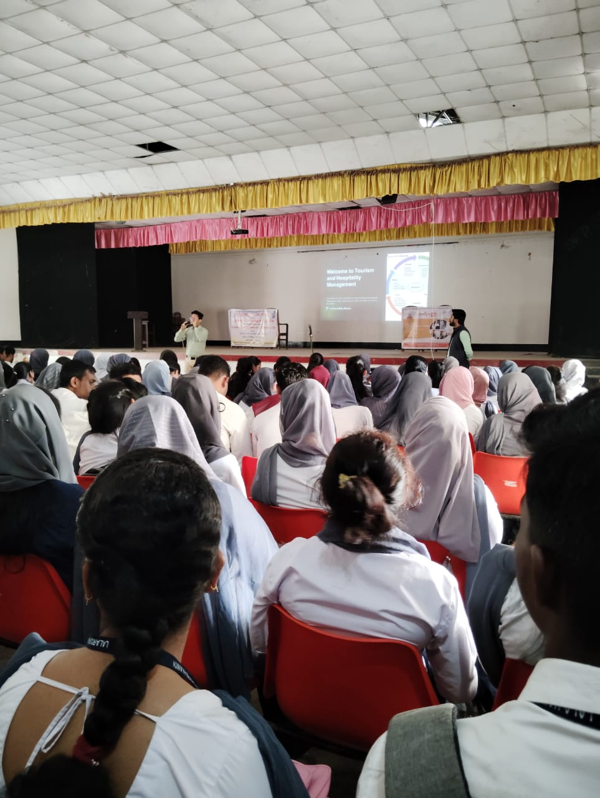

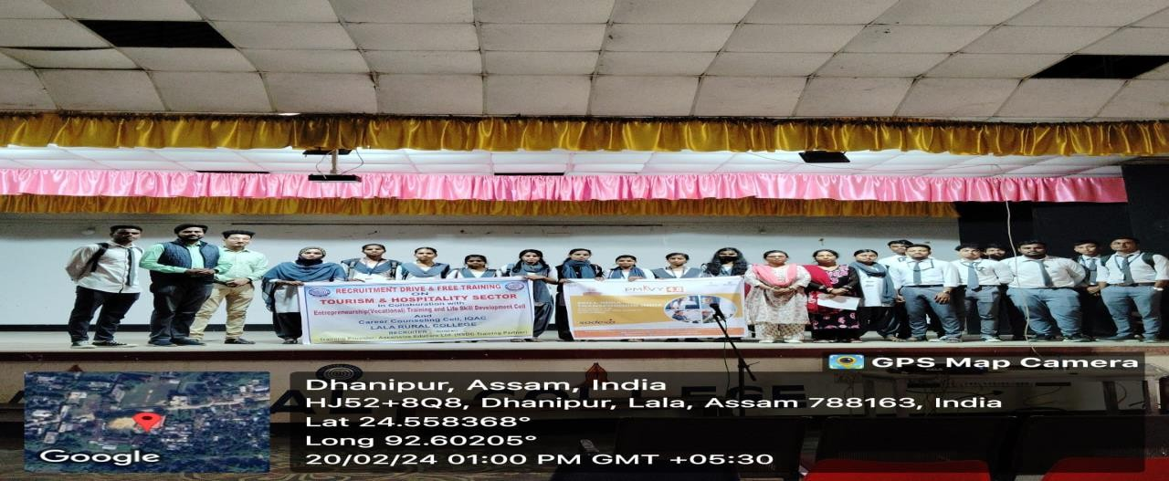

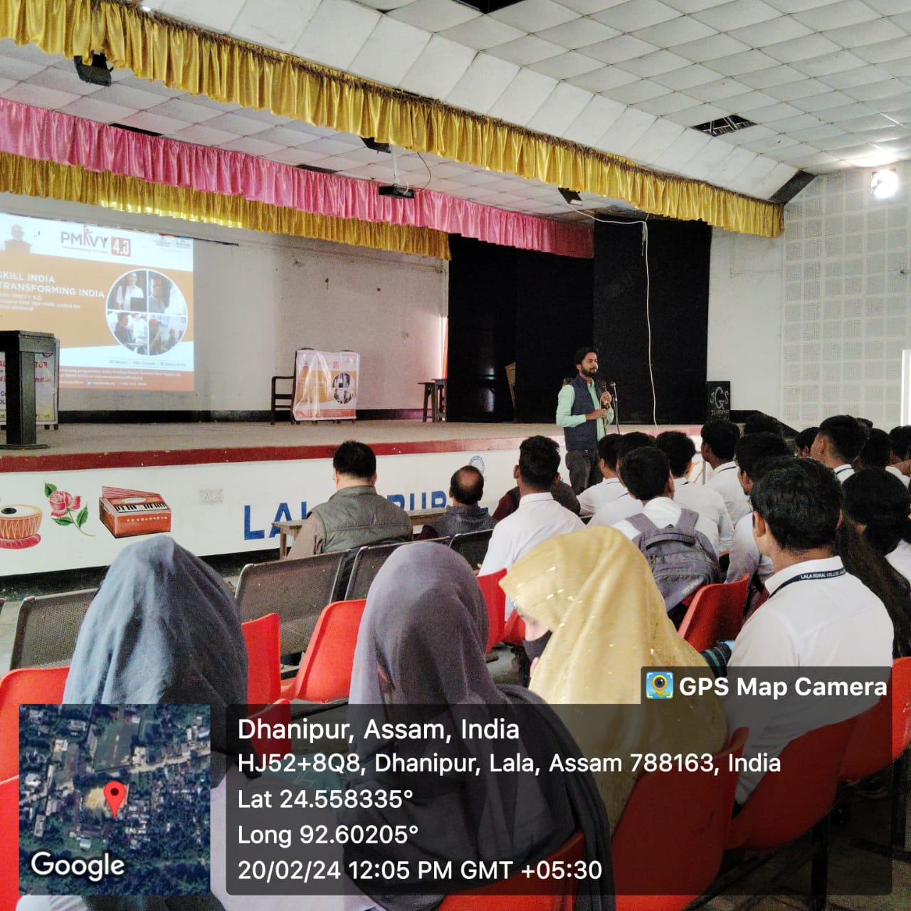

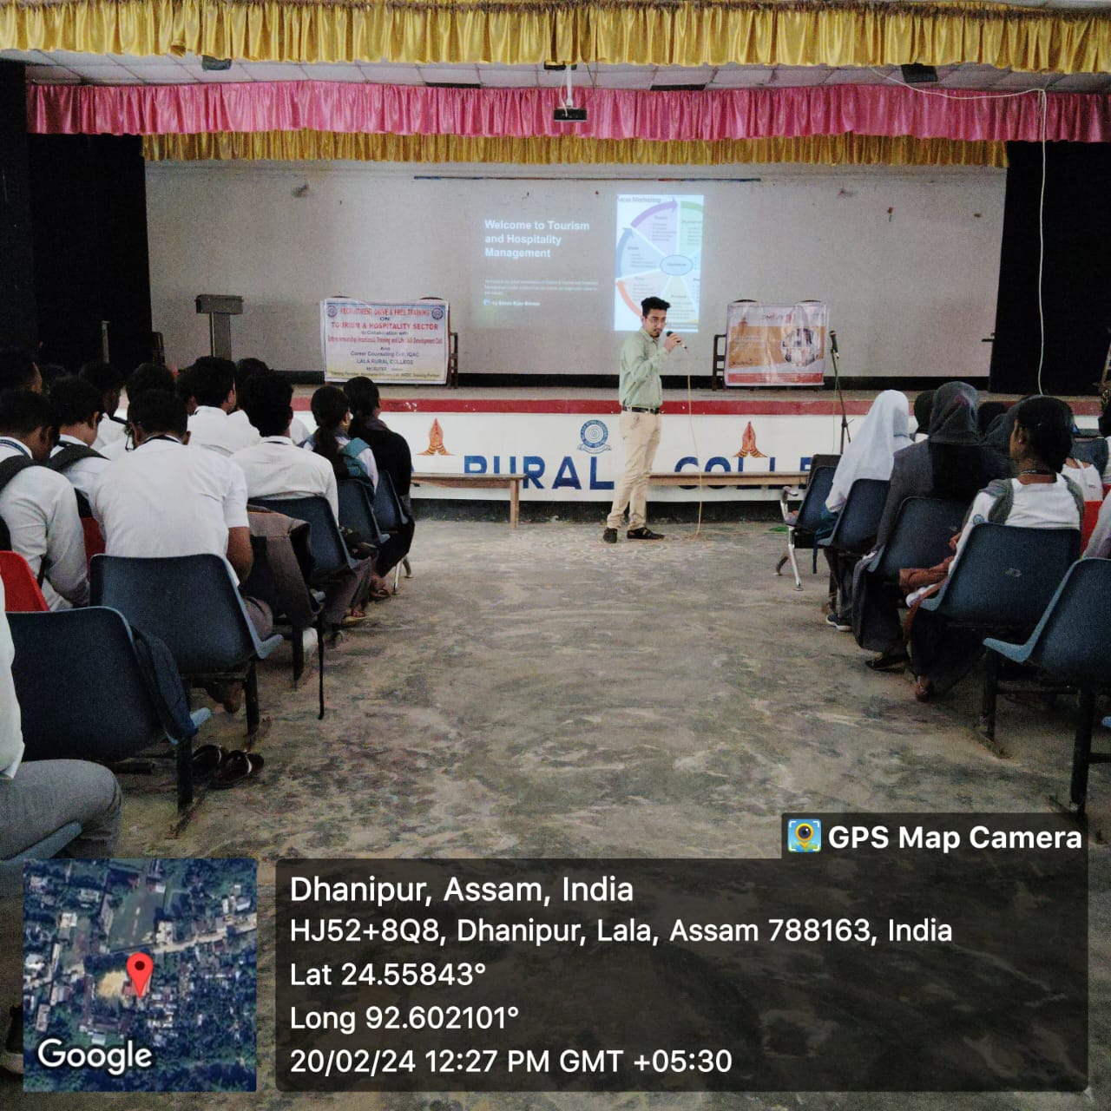
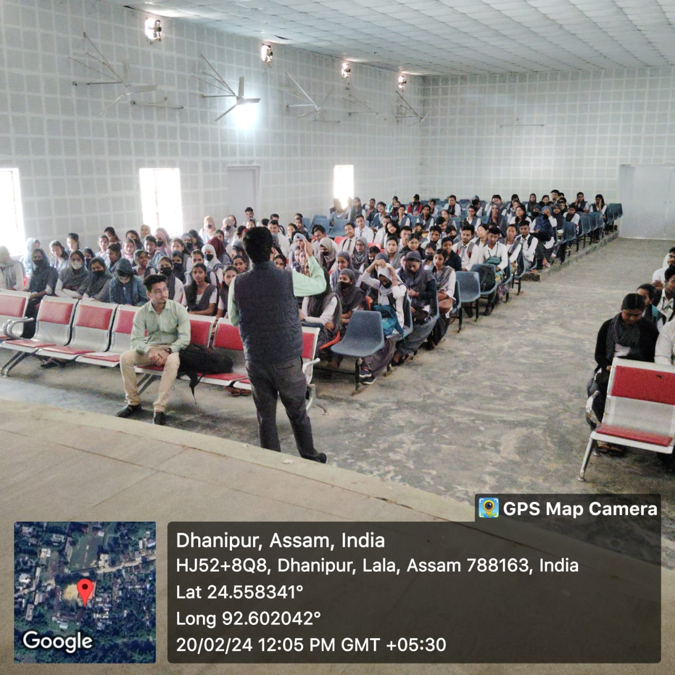

A Report on one-day Awareness Programme on “Bio-resource and Bio-entrepreneurship”

Organized by
Commerce Department,

Entrepreneurship (Vocational) Training and Life Skill Development Cell And
Career Counseling Cell, Lala Rural College
In collaboration with
Bio-Resource Complex (BRC), S.S College, Hailakandi

Date: 09/04/ 2024
Venue: Commerce Block, Lala Rural College
Time: 10 am to 12.00 pm

A “one day” awareness programme was held at Lala Rural College on “Bio-resource and Bio- entrepreneurship” for TDC final year students. The programme was organized jointly by the Commerce Department, Career Counseling Cell and Entrepreneurship (Vocational) Training and Life Skill Development Cell of the College in collaboration with Bio-resource Complex (BRC), S.S College, Hailakandi.
Dr. Debasish Guha Thakurata, Chief Coordinator and Principal Project Investigator, Bio- resource Complex, S.S College, Hailakandi was the resource person of the programme. The Programme was compered by Dr. Sonali Roy, convenor, Entrepreneurship (Vocational) Training and Life Skill Development Cell. The session was held in Room no. 16 (Commerce block) of the college. It started with an introductory speech and welcome address by Dr. Himabrata Chakravarty, Principal, Lala Rural College, Lala. Dr Debasish Guha Thakurata and his fellow members were then felicitated by the Principal and Mrs. Deepmala Paul, convenor, Career Counseling Cell respectively. Dr. Debasish Guha Thakurata delivered a wonderful speech highlighting the facilities provided by bio-resource complex to manage various biological resources, such as plants, fertilizers etc. He also introduced to the students with the various aims of the complex which includes -to identify, document, standardize, and promote indigenous practices among rural communities, highlighting the importance of these resources in various applications.
He emphasized the process of turning ideas into real applicable projects and discussed the contribution of BRC Hailakandi-IITG which adopted two form of entrepreneurship development models-first one being single stage model where the SHG members, individuals and students from Hailakandi are trained and empowered to start their own enterprise. The second model targets any start up based in Hailakandi or elsewhere but has a backward or forward linkage. Such Start-ups are empowered with the technical and managerial innovation which can further create secondary entrepreneurs from Hailakandi.
He introduced the concept of ‘design thinking’ and put forward numerous examples of successful local entrepreneurs. He explained how Bio Resource Complex at SS College Hailakandi and IITG has developed pilot plant level facility for dried, powder and extract type of products from different plants which is being used for training and demonstration, contract manufacturing, and process development. The facility is handholding over 50 SHG members and created one Start up for medicinal mushroom recently. BRC has established a forward linkage
with Tholua India for Entrepreneurs, active in the area of dehydrated fruits and vegetables. The BRC is evolving into an important facility for local bodies like NULM, NRLM, KVK, District Administration etc. Also, this facility has been identified as a possible vital centre of many Sustainability (CSR) projects.
The members of the BRC team along with their Project Investigator Dr. Debasish Guha Thakurata were applauded for their achievements after which he engaged in an interactive session with the attending teachers and students. 75 number of students along with some of the teachers participated in the event. The programme ended with a vote of thanks from Mr. Gautam Chandra Banik, Assistant Professor, Department of Commerce.
The orientation programme was highly successful, providing students with valuable entrepreneurial knowledge and insights into the future potential of bio-entrepreneurship in the Hailakandi district.


Dr. Sonali Roy, Convenor
Entrepreneurship (Vocational) Training and Life Skill Development Cell
Enclosure:

- Photographs
- Attendance Sheet

Photographs of the programme

